CS-640

ADVANCED DATABASE SYSTEM

Project Phase-2

BY,

Neeraja kareti

Ramtej Gajula

Ravi Krishna teja jalla

Jangam Rajiv Roy

Basheer shaik

1. **Write appropriate SQL DDL statements to define the database**

**PATIENT:**

CREATE TABLE PATIENT (

P_ssn INTEGER(15) NOT NULL,

P_name CHAR(15) NOT NULL,

Gender CHAR(20) NOT NULL,

Age INTEGER(4) NOT NULL,

Phone INTEGER(10) NOT NULL,

Address VARCHAR(20) NOT NULL,

Patient_health_prb VARCHAR(25) NOT NULL,

City VARCHAR(20) NOT NULL,

Zip_code INTEGER(10) NOT NULL,

PRIMARY KEY(P_ssn),

FOREIGN KEY(P_name) REFERENCES DOCTOR (P_name),

FOREIGN KEY(P_name) REFERENCES NURSE (P_name),

FOREIGN KEY(P_name) REFERENCES PAYMENT (P_name),

FOREIGN KEY(P_name) REFERENCES INSURANCE (P_name),

FOREIGN KEY(P_name) REFERENCES PRESCRIPTION (P_name),

FOREIGN KEY(P_name) REFERENCES ADMIN (P_name)

);

Syntax validation:

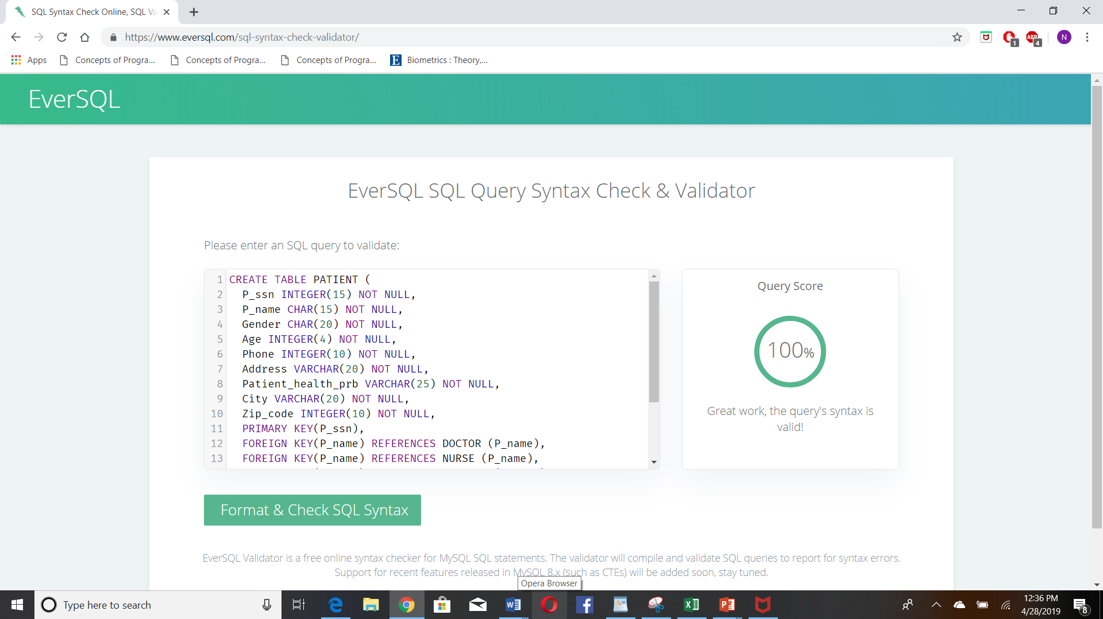

**DOCTOR:**

CREATE TABLE DOCTOR (

D_ssn INTEGER(15) NOT NULL,

D_name CHAR(15) NOT NULL,

Gender CHAR(20) NOT NULL,

Age INTEGER(4) NOT NULL,

Phone INTEGER(10) NOT NULL,

Address VARCHAR(20) NOT NULL,

Patient_health_prb VARCHAR(25) NOT NULL,

P_name VARCHAR(15) UNIQUE,

City VARCHAR(20) NOT NULL,

Zip_code INTEGER(10) NOT NULL,

Doc_office VARCHAR(25) NOT NULL,

Doc_comments VARCHAR(25) NOT NULL,

Nurse_comments VARCHAR(25) NOT NULL,

Doc_Prescription VARCHAR(25) NOT NULL,

PRIMARY KEY(D_ssn),

FOREIGN KEY(D_name) REFERENCES ADMIN (D_name),

FOREIGN KEY(P_name) REFERENCES NURSE (P_name),

FOREIGN KEY(Doc_comments) REFERENCES PRESCRIPTION (Doc_comments),

FOREIGN KEY(Nurse_comments) REFERENCES NURSE (Nurse_comments)

);

**Syntax Validation:**

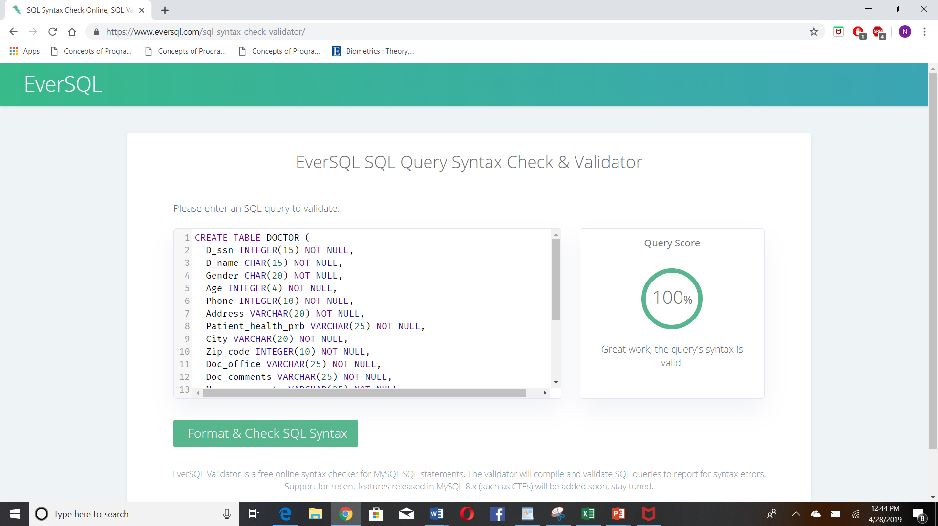

**NURSE:**

CREATE TABLE NURSE (

Nurse_ID INTEGER(15) NOT NULL,

Nurse_name CHAR(15) NOT NULL,

Gender CHAR(20) NOT NULL,

Age INTEGER(4) NOT NULL,

Phone INTEGER(10) NOT NULL,

Address VARCHAR(20) NOT NULL,

Patient_health_prb VARCHAR(25) NOT NULL,

P_name VARCHAR(15) UNIQUE,

Nurse_comments VARCHAR(25) NOT NULL,

PRIMARY KEY(Nurse_ID),

FOREIGN KEY(P_name) REFERENCES PATIENT (P_name)

);

**Syntax validation:**

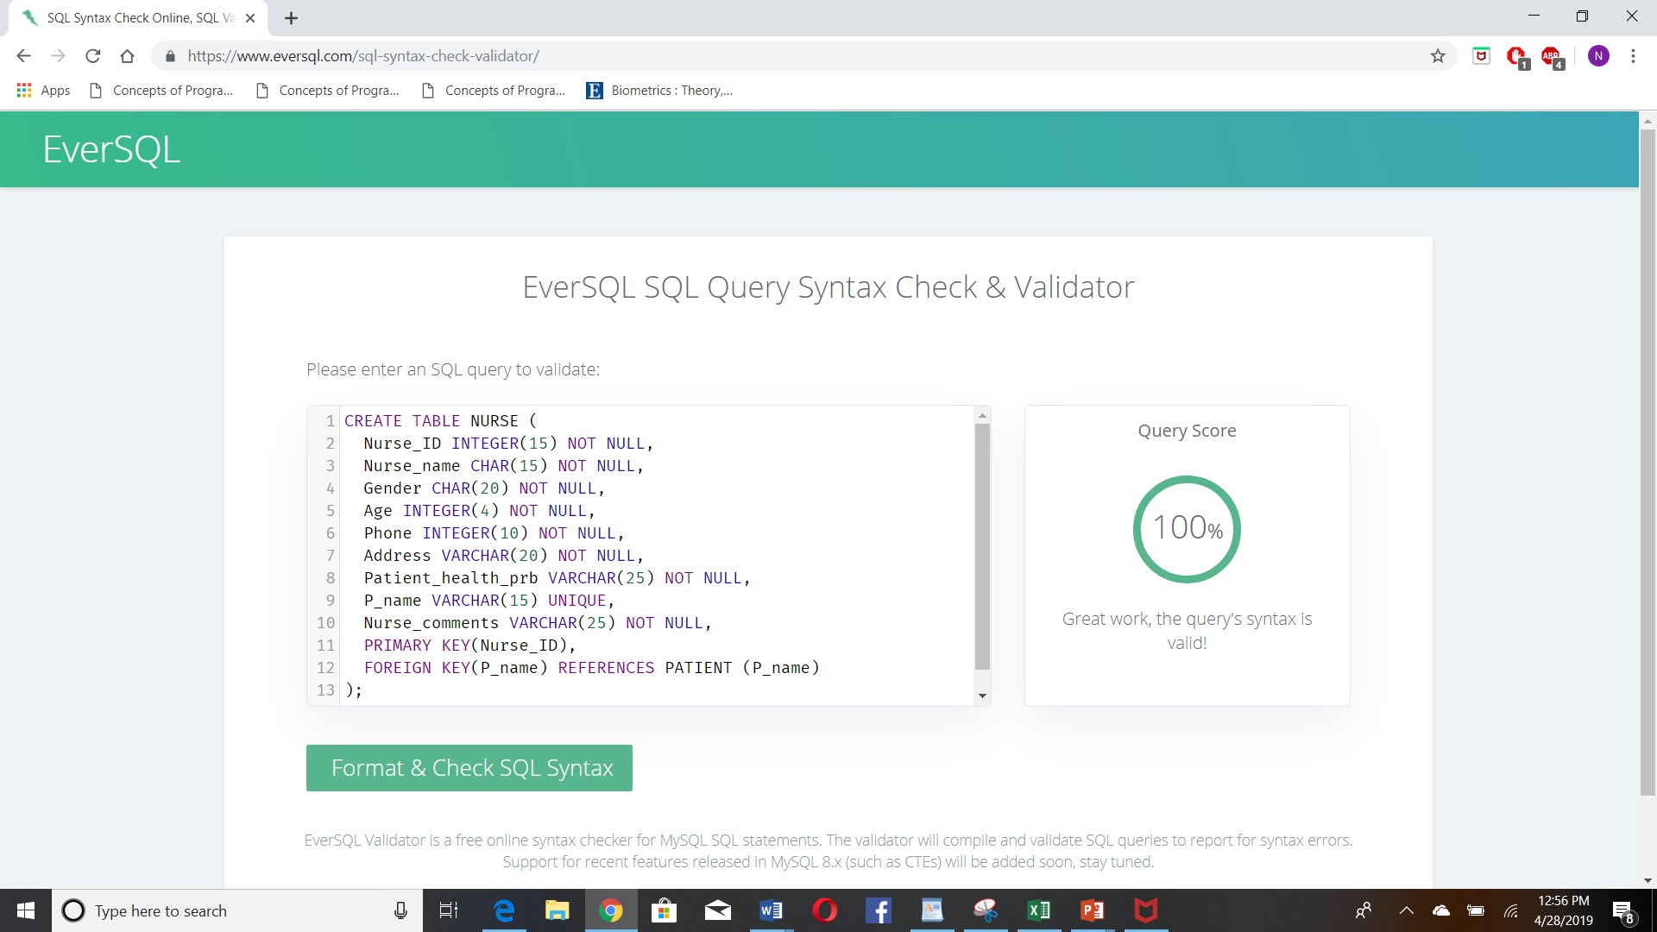

**PAYMENT:**

CREATE TABLE PAYMENT(

Invoice_no INTEGER(15) NOT NULL,

P_name CHAR(15) UNIQUE,

Payment_trans_no INTEGER(15) NOT NULL,

Payment_method VARCHAR(20) NOT NULL,

Payment_date DATE NOT NULL,

Payment_status VARCHAR(20) NOT NULL,

PRIMARY KEY(Invoice_no),

FOREIGN KEY(P_name) REFERENCES PATIENT (P_name)

);

**Syntax Validation:**

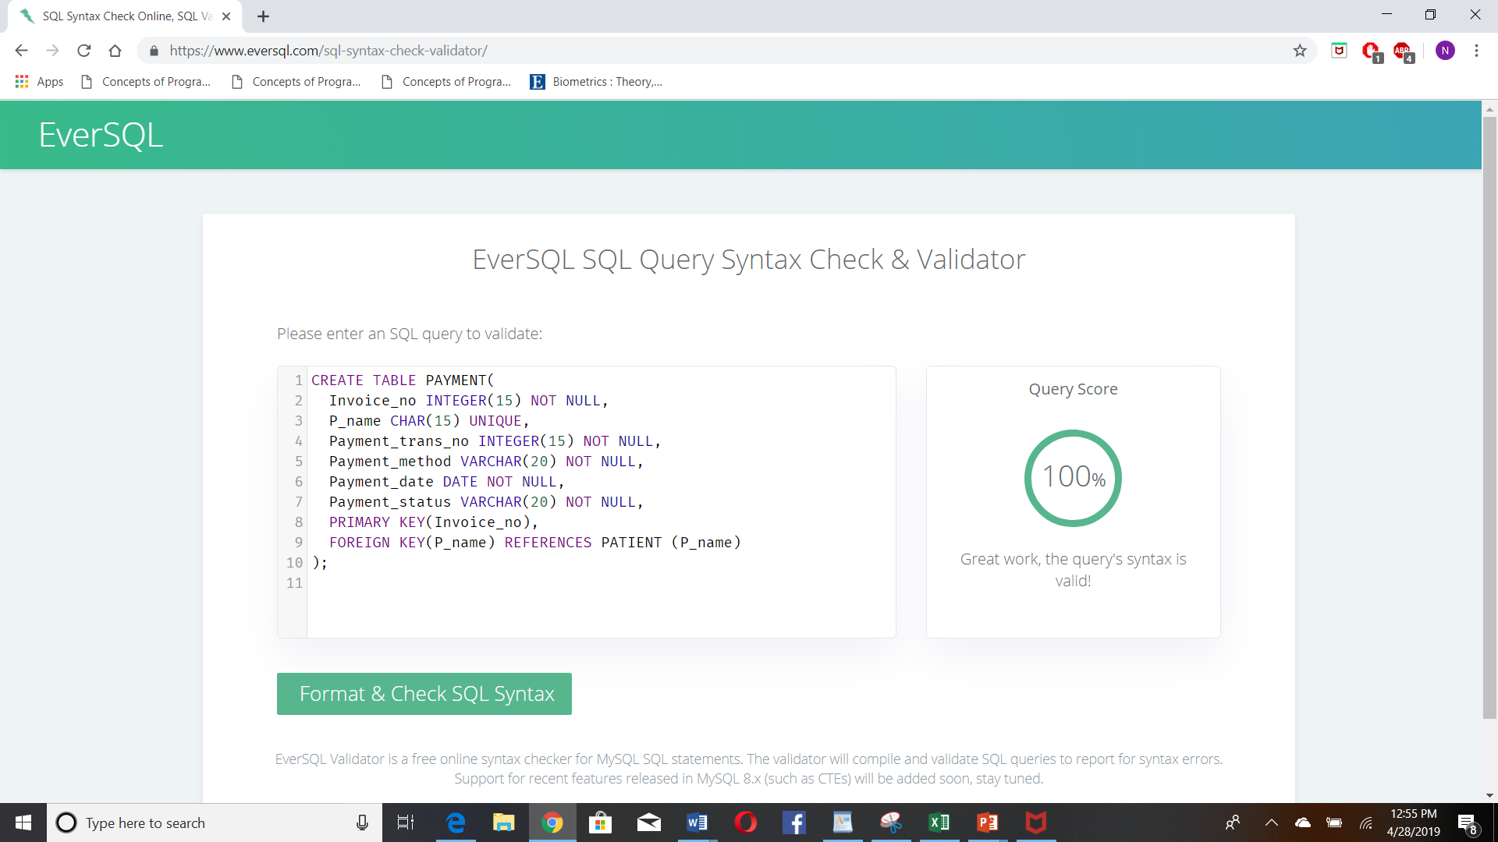

**Insurance:**

CREATE TABLE INSURANCE (

P_ssn INTEGER(15) UNIQUE,

P_name CHAR(15) NOT NULL,

Insurance_id INTEGER(10) NOT NULL,

Insurance_name CHAR(15) NOT NULL,

Category CHAR(10) NOT NULL,

Phone INTEGER(10) NOT NULL,

Address VARCHAR(20) NOT NULL,

City VARCHAR(20) NOT NULL,

Zip_code INTEGER(10) NOT NULL,

PRIMARY KEY(Insurance_id),

FOREIGN KEY(P_name, P_ssn) REFERENCES PATIENT (P_name, P_ssn)

);

**Syntax Validation:**

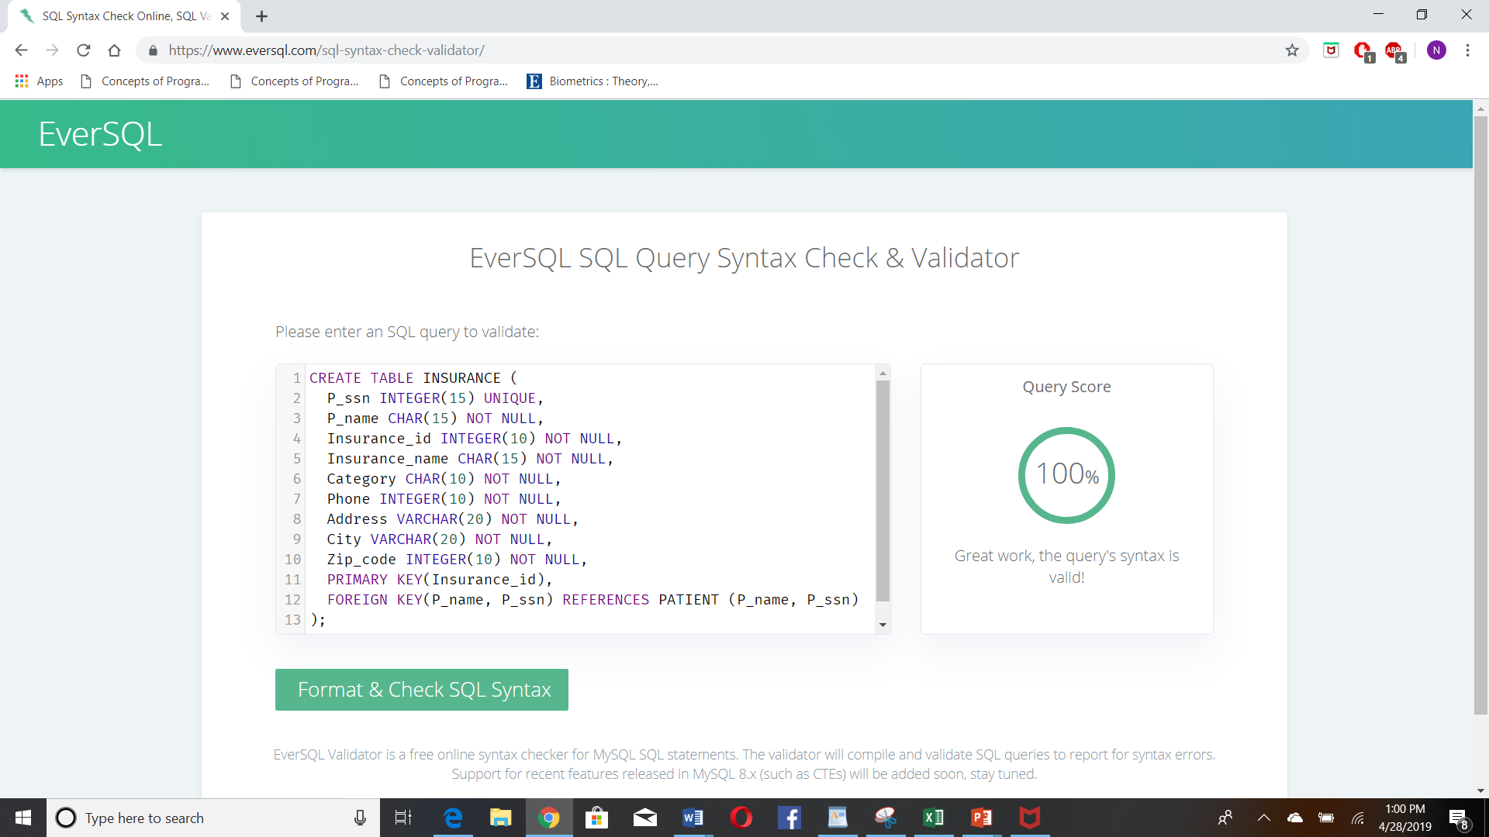

**PRESCRIPTION:**

CREATE TABLE PRESCRIPTION(

Prescription_id INTEGER(15) NOT NULL,

P_name CHAR(15) UNIQUE,

Doc_comments VARCHAR(20) NOT NULL,

Medicine_list VARCHAR(20) NOT NULL,

PRIMARY KEY(Precription_id),

FOREIGN KEY(P_name) REFERENCES PATIENT (P_name),

FOREIGN KEY(Doc_comments) REFERENCES DOCTOR (Doc_comments)

);

**Syntax Validation**

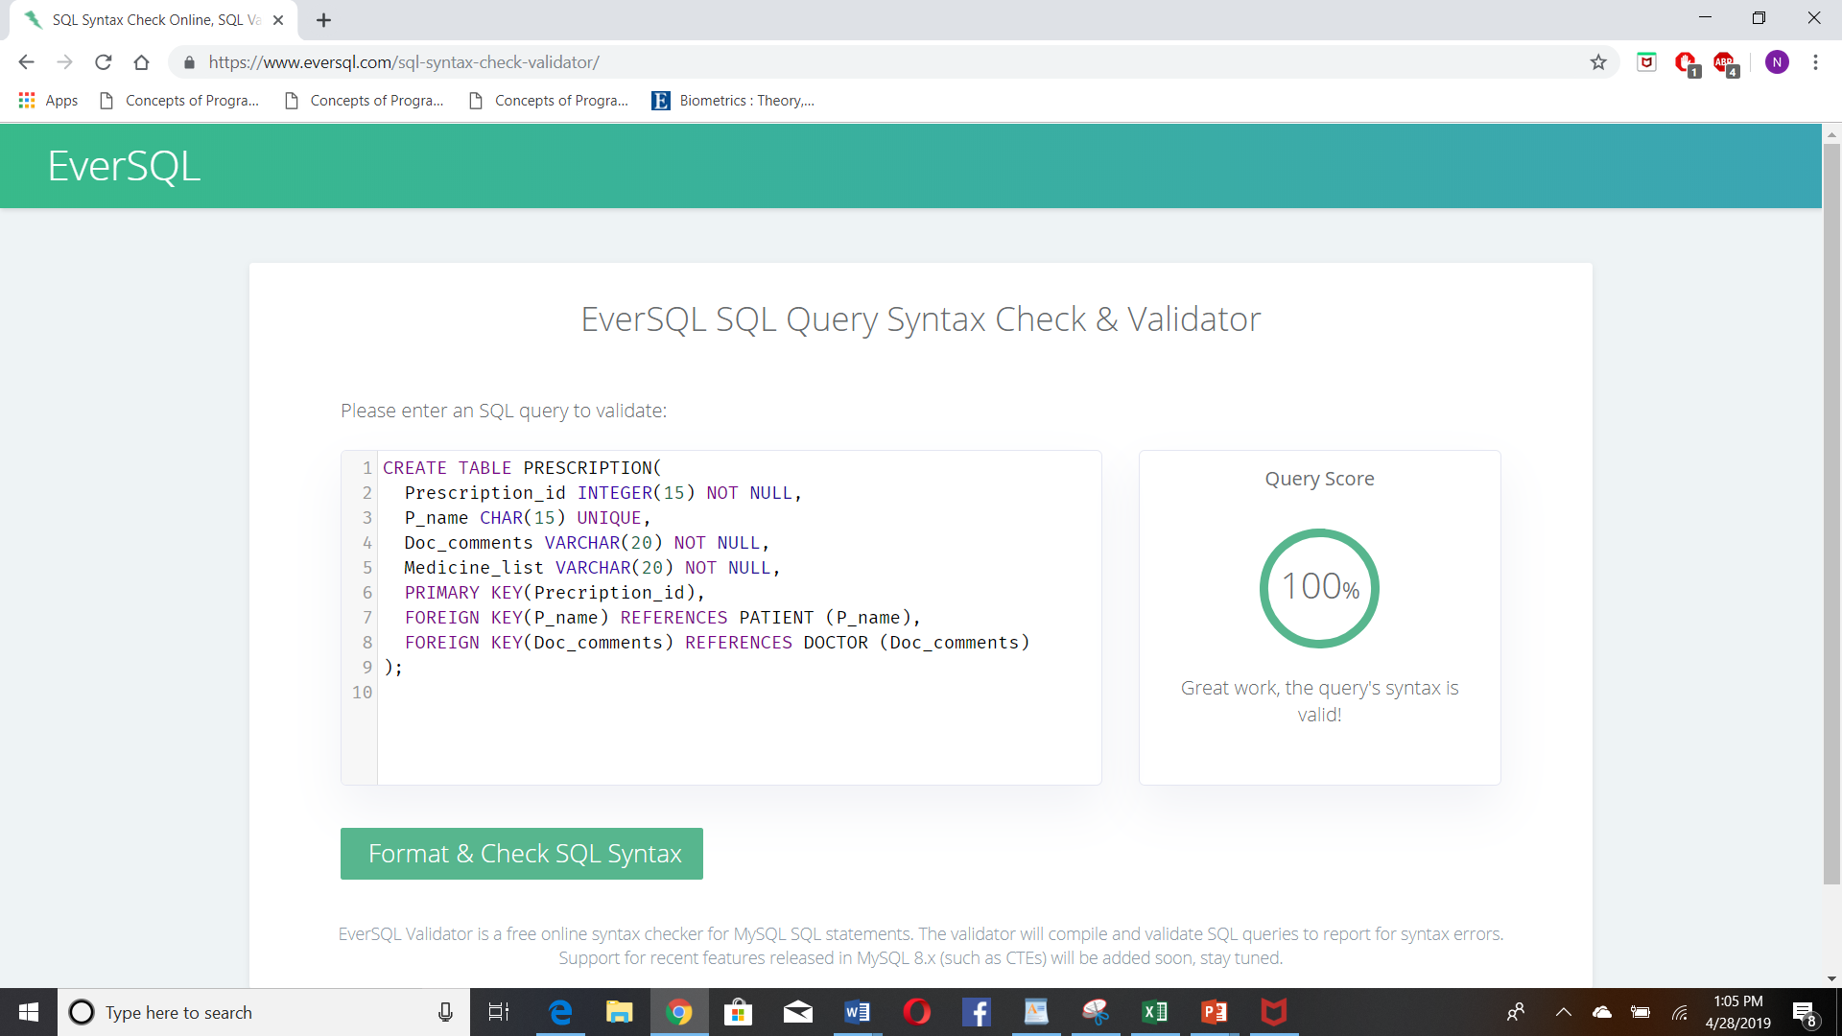

**Admin:**

CREATE TABLE ADMIN(

P_name CHAR(15) UNIQUE,

D_name CHAR(15) UNIQUE,

Payment CHAR(10) NOT NULL,

Health_details VARCHAR(20) NOT NULL,

Invoice_no INTEGER(10) NOT NULL,

FOREIGN KEY(P_name) REFERENCES PATIENT (P_name),

FOREIGN KEY(D_name) REFERENCES DOCTOR (D_name),

FOREIGN KEY(Invoice_no) REFERENCES PAYMENT(Invoice_no)

);

**Syntax validation:**

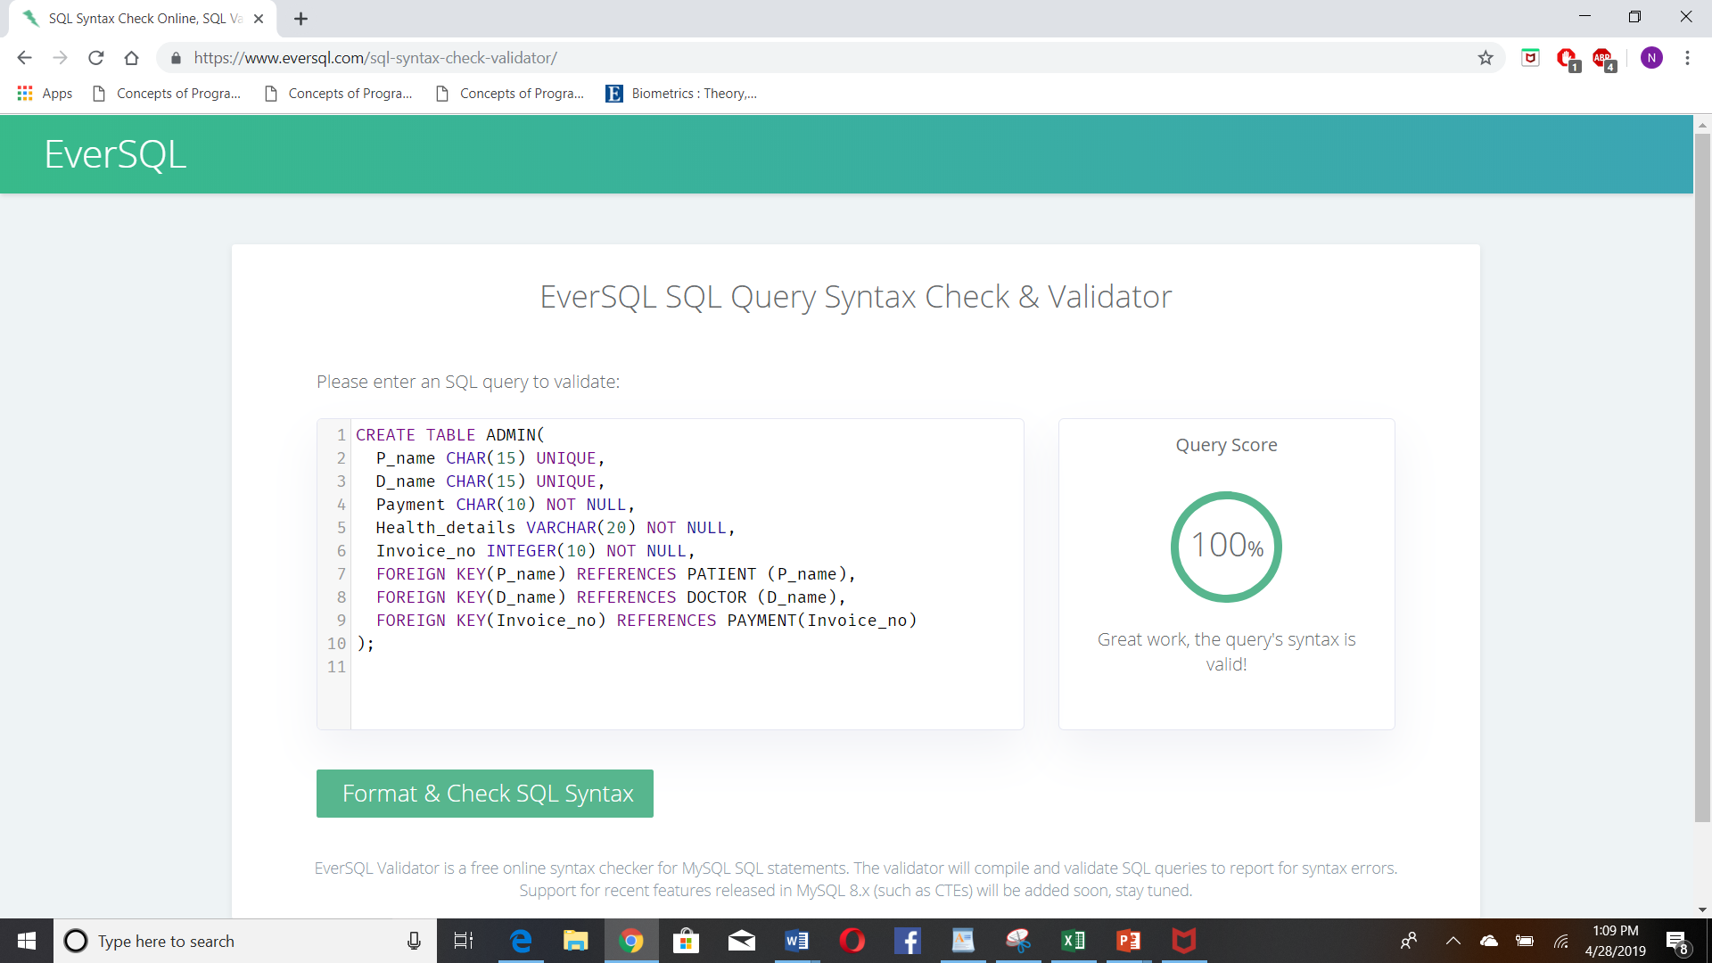

1. **Specify the queries in SQL on the database schema of your project.**

**PATIENT:**

SELECT * FROM HOSPITAL.PATIENT;

**DOCTOR:**

SELECT * FROM DOCTOR WHERE (SELECT p.P_name, d.P_name FROM PATIENT AS p, DOCTOR AS d WHERE p.P_name = d.P_name);

**Syntax Check:**

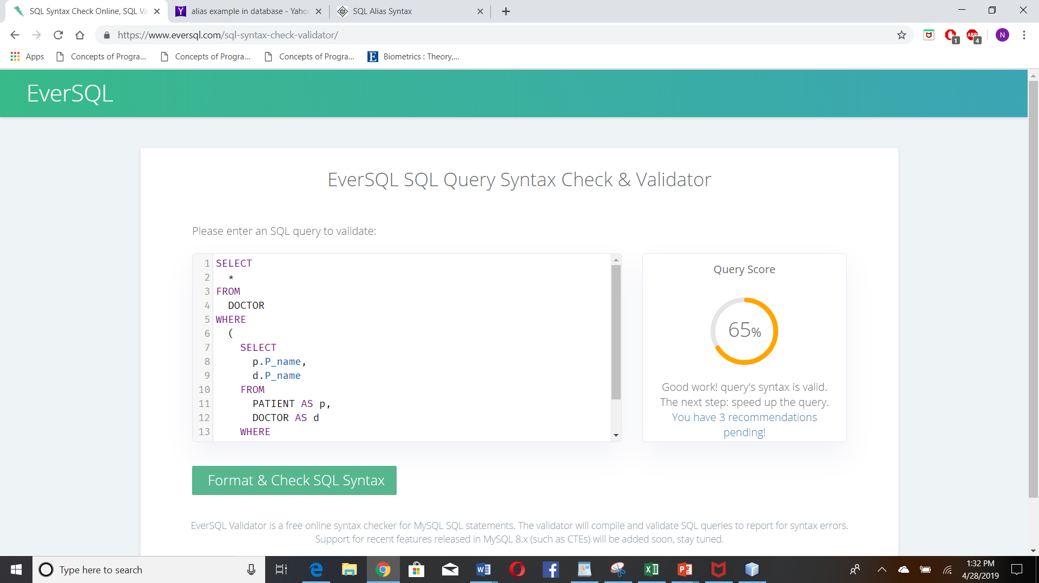

**Nurse:**

SELECT * FROM NURSE WHERE (SELECT p.P_name, n.P_name FROM PATIENT AS p, NURSE AS n WHERE p.P_name = n.P_name);

**Syntax Check:**

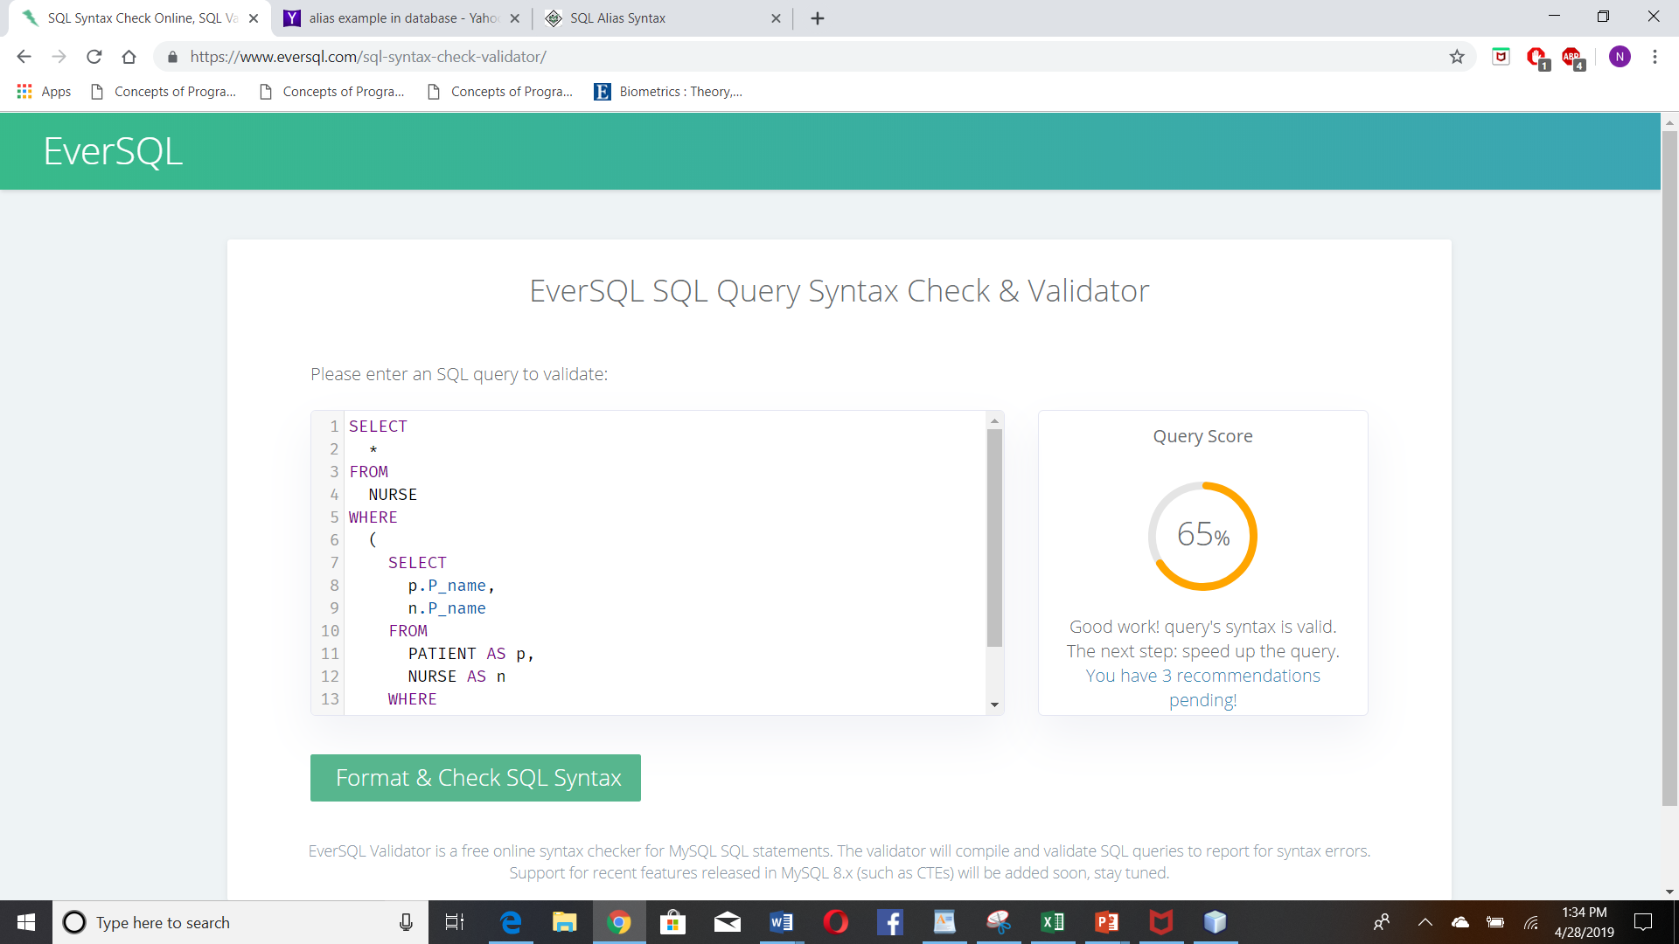

**Payment:**

SELECT * FROM PAYMENT WHERE (SELECT p.P_name, py.P_name FROM PATIENT AS p, PAYMENT AS py WHERE p.P_name = py.P_name);

**Syntax Check:**

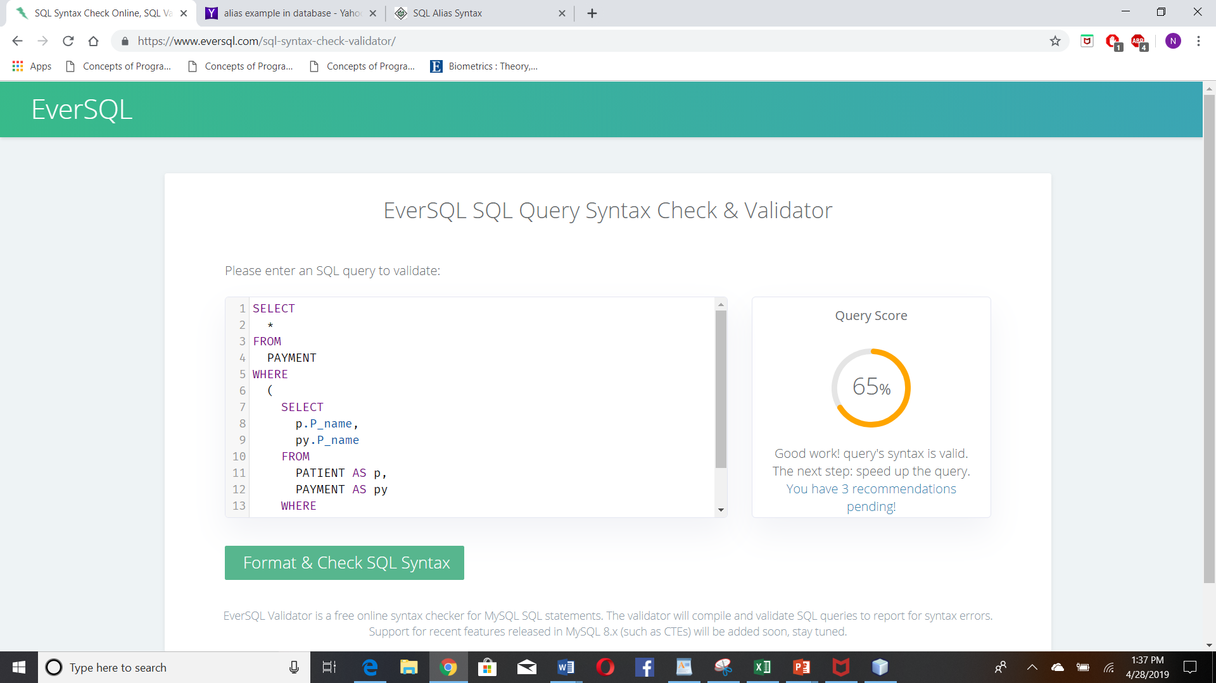

**Insurance:**

SELECT * FROM INSURANCE WHERE (SELECT p.P_name, i.P_name, p.P_ssn, i.P_ssn FROM PATIENT AS p, INSURANCE AS i WHERE p.P_name = i.P_name and p.P_ssn and i.P_ssn);

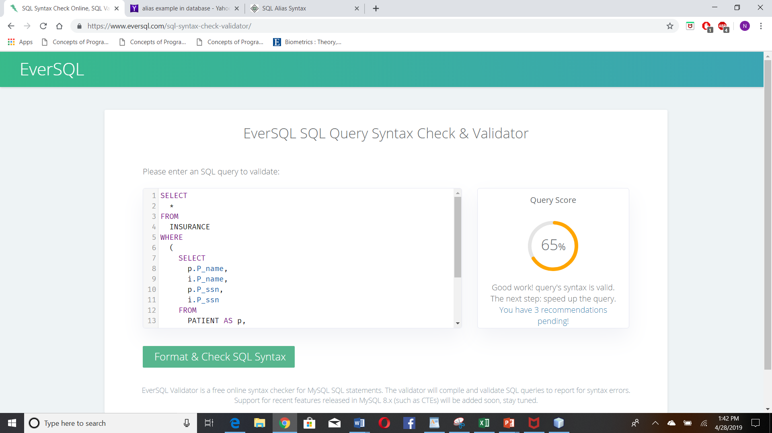

**Prescription**

SELECT * FROM PRESCRIPTION WHERE (SELECT p.P_name, pr.P_name, d.Doc_comments, pr.Doc_comments FROM PATIENT AS p, DOCTOR AS d, PRESCRIPTION AS pr WHERE p.P_name = pr.P_name AND d.Doc_comments = pr.Doc_comments);

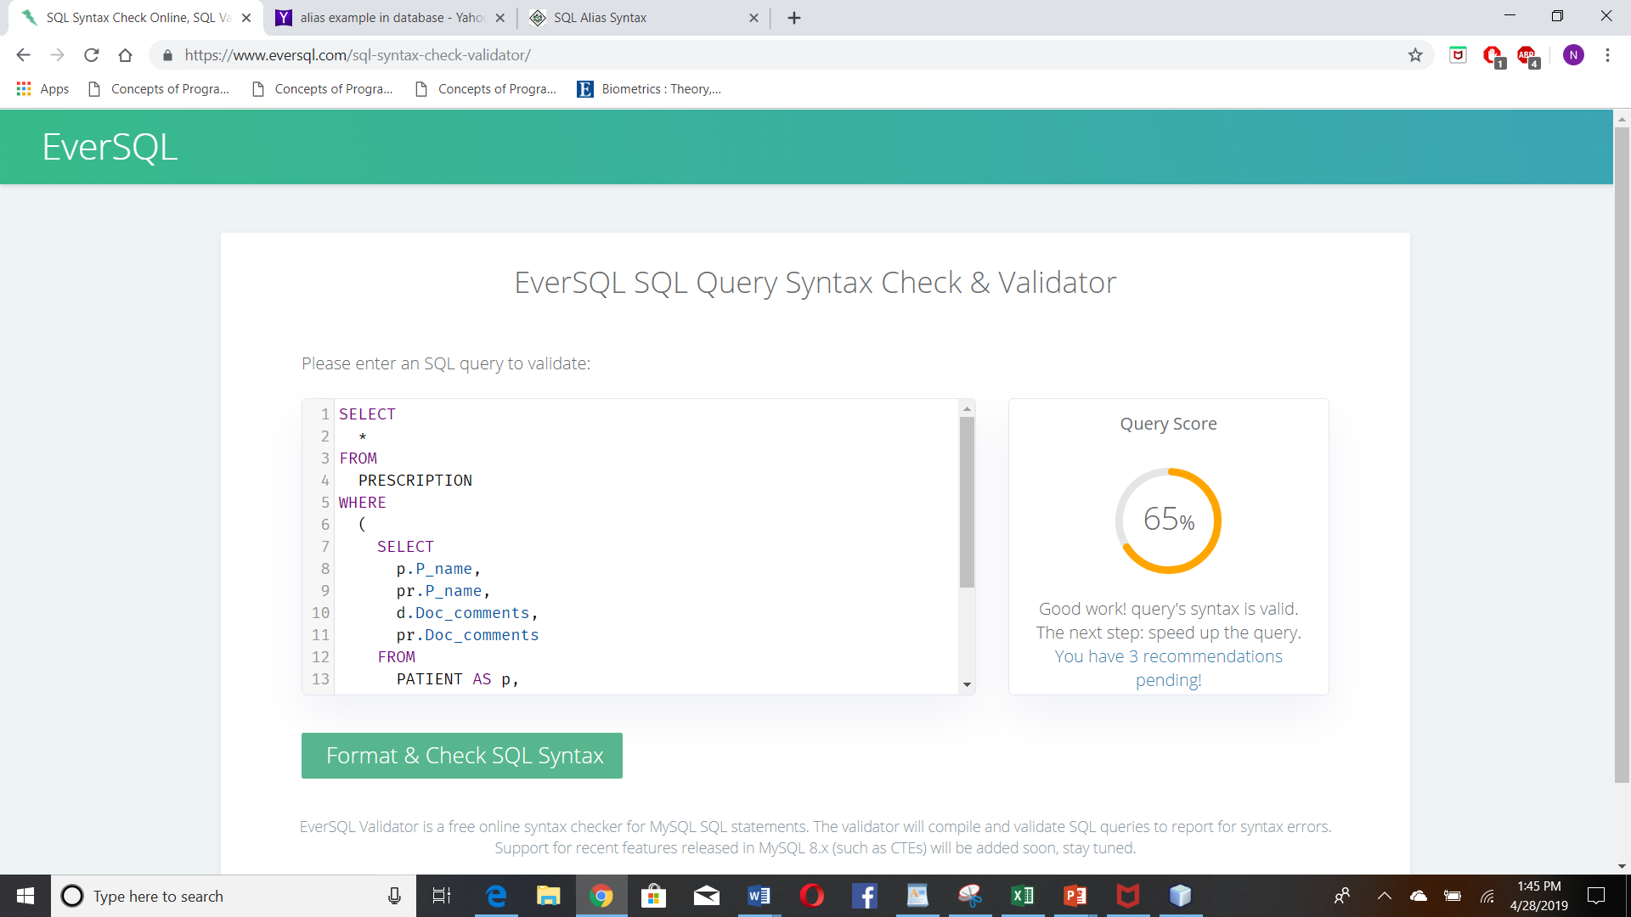

**Admin**

SELECT p.P_name, d.D_name, a.payment, p.health_details, py.invoice_no FROM PATIENT AS p, DOCTOR AS d, PAYMENT AS py, ADMIN AS a;

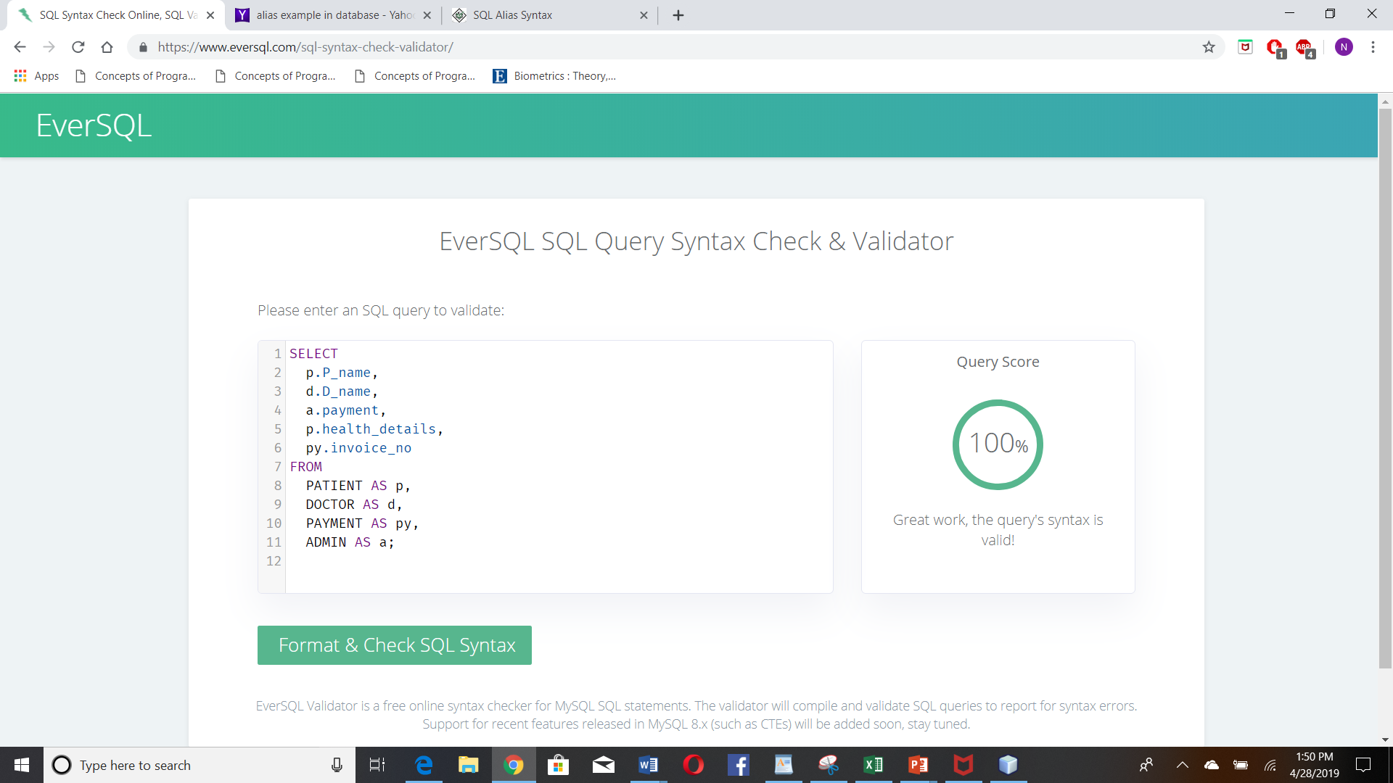

1. **Carry out the steps of the ER-to-Relational mapping algorithm on the ER diagram of your database**

|  |  |  |  |  |  |  |  |  |
| --- | --- | --- | --- | --- | --- | --- | --- | --- |
| P_Name | P_SSN | Gender | Age | Phone | Address | Patient_health_prb | City | Zip_Code |

|  |  |  |  |  |  |  |  |  |  |  |
| --- | --- | --- | --- | --- | --- | --- | --- | --- | --- | --- |
| D_Name | P_name | D_SSN | Gender | Age | Phone | Address  Zipcode | City | Doctor office | Patient health problem | Doctor comms |

|  |  |  |  |  |  |  |  |
| --- | --- | --- | --- | --- | --- | --- | --- |
| P_Name | Nurse_Name | Nurse_ID | Gender | Patient_health  Problem | Age | Phone | Nurse_Comments |

|  |  |  |  |  |  |
| --- | --- | --- | --- | --- | --- |
| P_Name | Invoice_Num | Payment_trans_num | Pay_Method | Payment_date | Payment_status |

|  |  |  |  |  |  |  |  |  |
| --- | --- | --- | --- | --- | --- | --- | --- | --- |
| P_name | P_ssn | Insurance_id | Insurance_Name | Insurance_category | Phone_n.o | Address | City | Zip_Code |

|  |  |  |  |
| --- | --- | --- | --- |
| P_name | Prescription_ID | Doctor_Comments | Medicine_list |

|  |  |  |  |  |
| --- | --- | --- | --- | --- |
| P_Name | D_Name | Payment | Health_Details | Invoice_Num |

**STEP 1-Mapping of regular entity types**

We make relations pname, pssn, and dname and patient health type in the social blueprint comparing to the ordinary substances in the ER outline. Pname, health details, invoice number in payment are the essential keys for the relations referenced above for the undertaking appear.

**STEP 2- Mapping weak entity type:**

Make the relations nname, pname, payment type which are the weak substances. Incorporate the essential keys from the standard elements as outside key characteristics for the powerless substances.

**STEP 3 - Mapping of Binary 1:1 relation type**

In the ER diagram we can see the relationships on each entity with each other’s relevance

Pname to Dname M:M

Dname to Nname 1:N

Health problem to Dname 1:N

Invoice to payment N:1

City to zipcode 1:N

pname to phone number N:1

**STEP 4 – Mapping of binary 1: N relationship types**

Distinguishing their relationship and after that incorporate remote keys in the relations with the relations with essential keys in which each other taking an interest. For p name and d name we incorporate the essential key. you need to associate frail substances with normal elements and their outside and essential keys, however they ought to have 1:N connections.

**STEP 5 – Mapping Binary M: N relationship types**

For every ordinary paired M: N relationship type R, make another connection S to speak to R. This is a relationship connection. Incorporate as outside key qualities in S the essential keys of the relations that speak to the taking part substance types; their mix will shape the essential key of S. For instance the essential keys of the pname and dname relations are incorporated as M: N through health problems and they go about as outside and essential keys to one another.

**STEP 6 - Mapping of Multivalued attributes**

For each multivalued property make a connection. On the off chance that the multivalued quality is composite, we incorporate its straightforward segments. In this way, we need to check whether there are any multivalued ascribes we need to check their remote and essential keys speaking to that connection.

**STEP 7- Mapping of binary relationship types**

This shows the schema into the relational database

|  |  |  |  |  |  |  |  |  |
| --- | --- | --- | --- | --- | --- | --- | --- | --- |
| P_Name | P_SSN | Gender | Age | Phone | Address | Patient_health_prb | City | Zip_Code |

|  |  |  |  |  |  |  |  |  |  |  |
| --- | --- | --- | --- | --- | --- | --- | --- | --- | --- | --- |
| D_Name | P_name | D_SSN | Gender | Age | Phone | Address  Zipcode | City | Doctor office | Patient health problem | Doctor comms |

|  |  |  |  |  |  |  |  |
| --- | --- | --- | --- | --- | --- | --- | --- |
| P_Name | Nurse_Name | Nurse_ID | Gender | Patient_health  Problem | Age | Phone | Nurse_Comments |

|  |  |  |  |  |  |
| --- | --- | --- | --- | --- | --- |
| P_Name | Invoice_Num | Payment_trans_num | Pay_Method | Payment_date | Payment_status |

|  |  |  |  |  |  |  |  |  |
| --- | --- | --- | --- | --- | --- | --- | --- | --- |
| P_name | P_ssn | Insurance_id | Insurance_Name | Insurance_category | Phone_n.o | Address | City | Zip_Code |

|  |  |  |  |
| --- | --- | --- | --- |
| P_name | Prescription_ID | Doctor_Comments | Medicine_list |

|  |  |  |  |  |
| --- | --- | --- | --- | --- |
| P_Name | D_Name | Payment | Health_Details | Invoice_Num |

**STEP 8 - Mapping of union types**

For mapping a classification whose characterizing superclass have distinctive keys, it is standard to determine another key characteristic, called a surrogate key, while making a connection to relate to the class.

1. **Mysql table structure:**

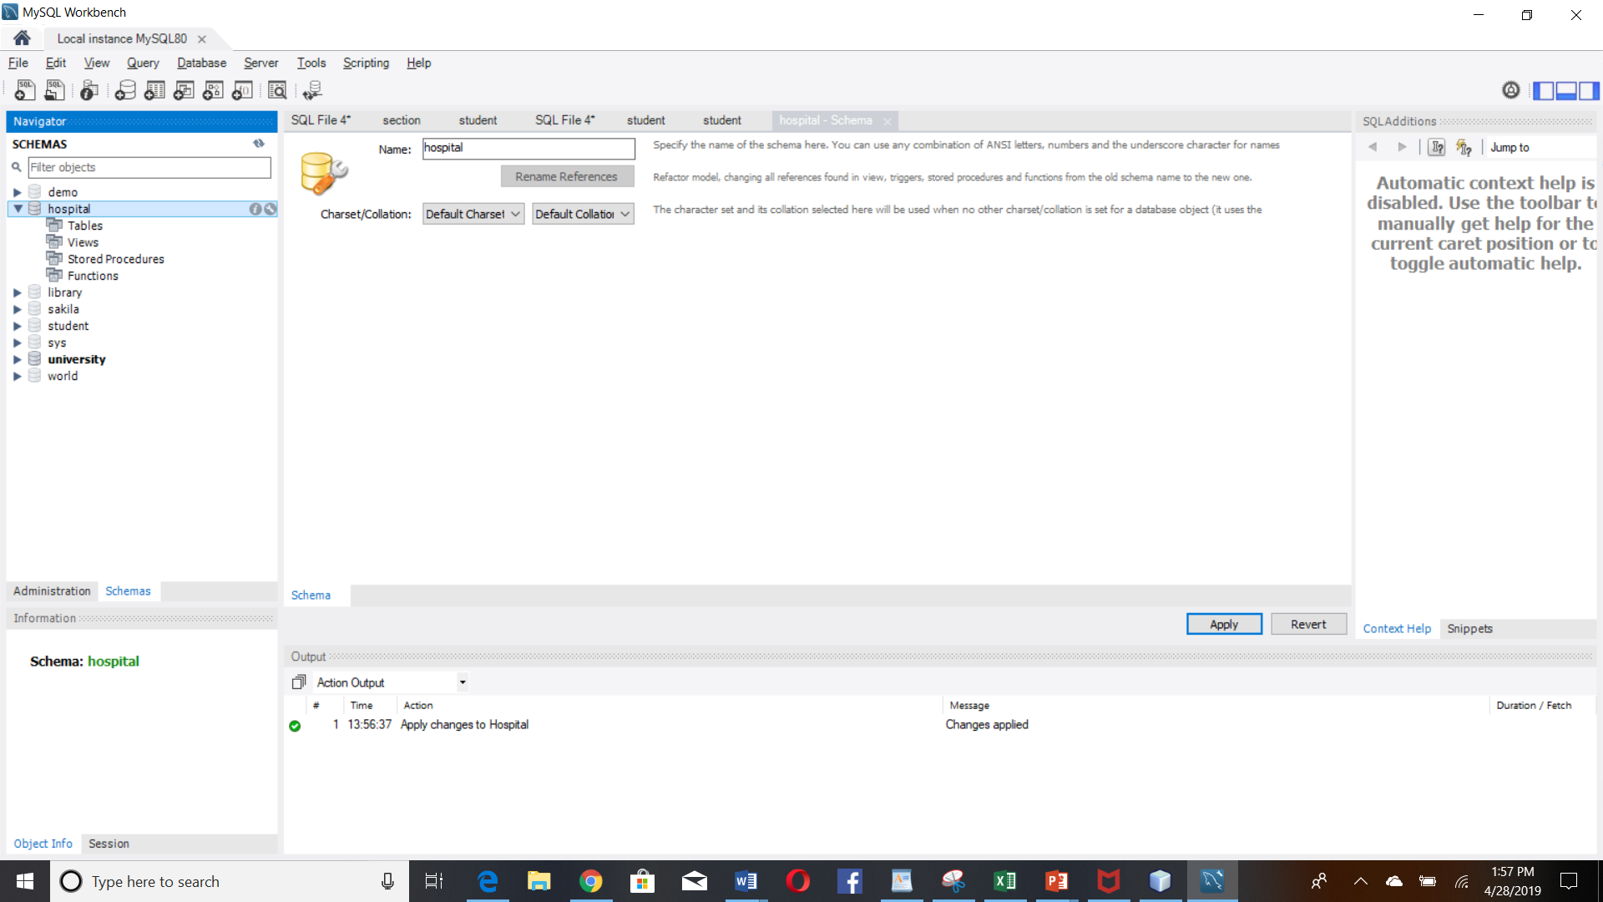

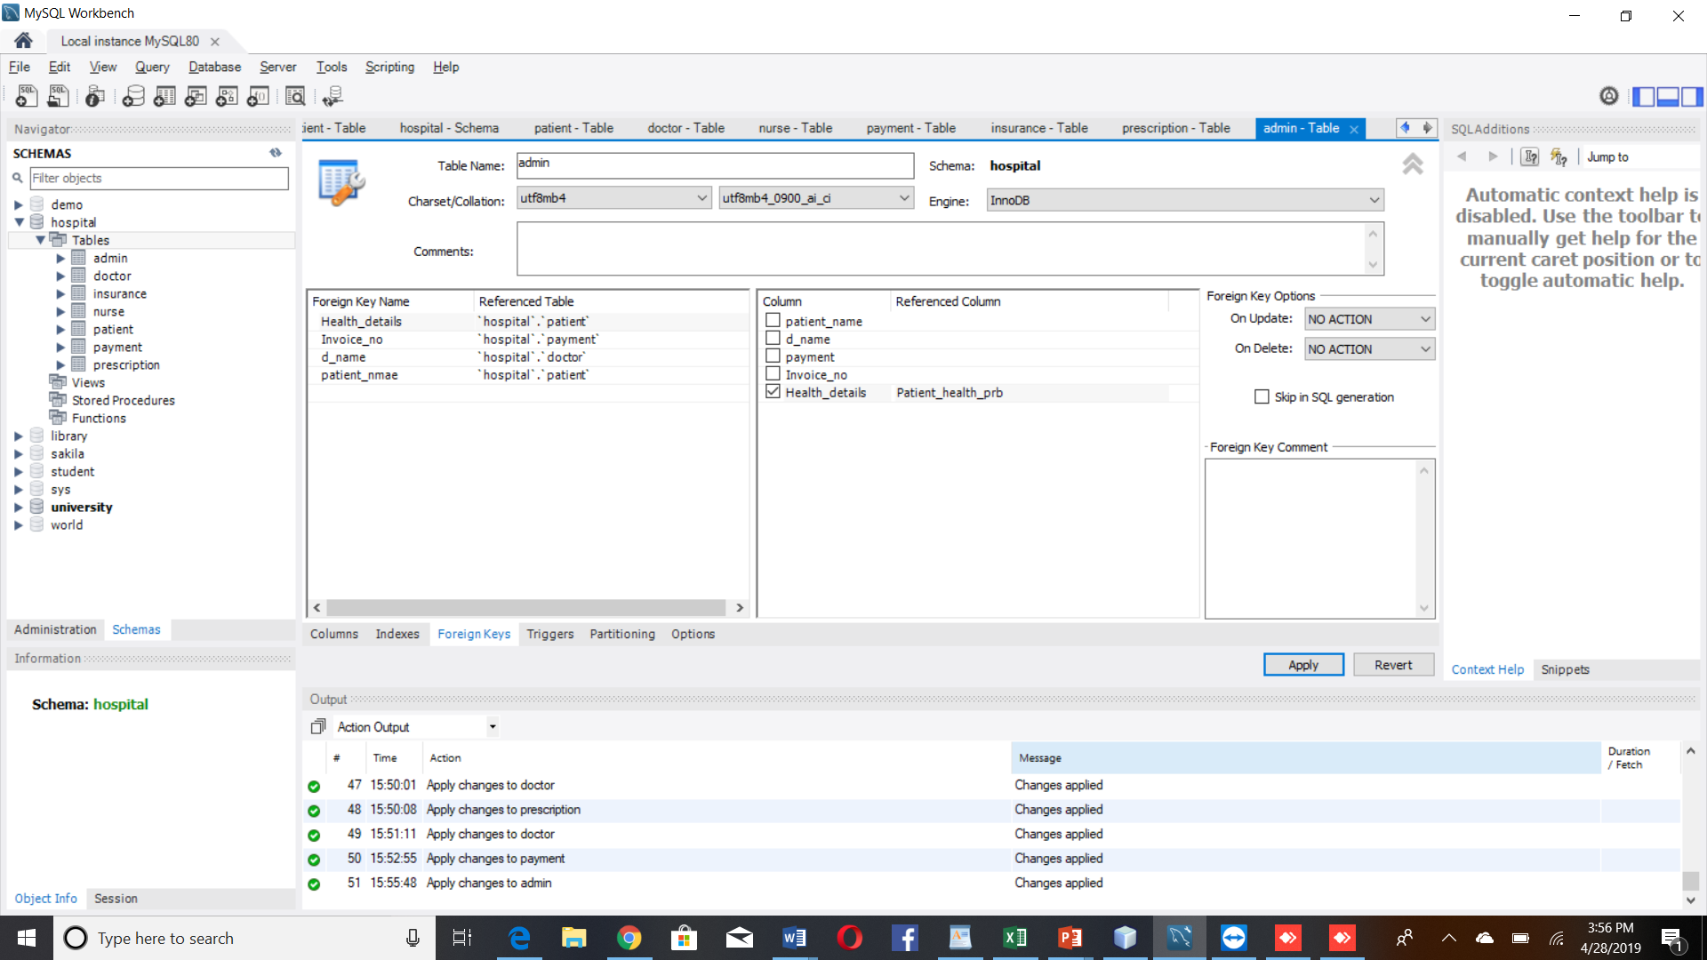

**Patient:**

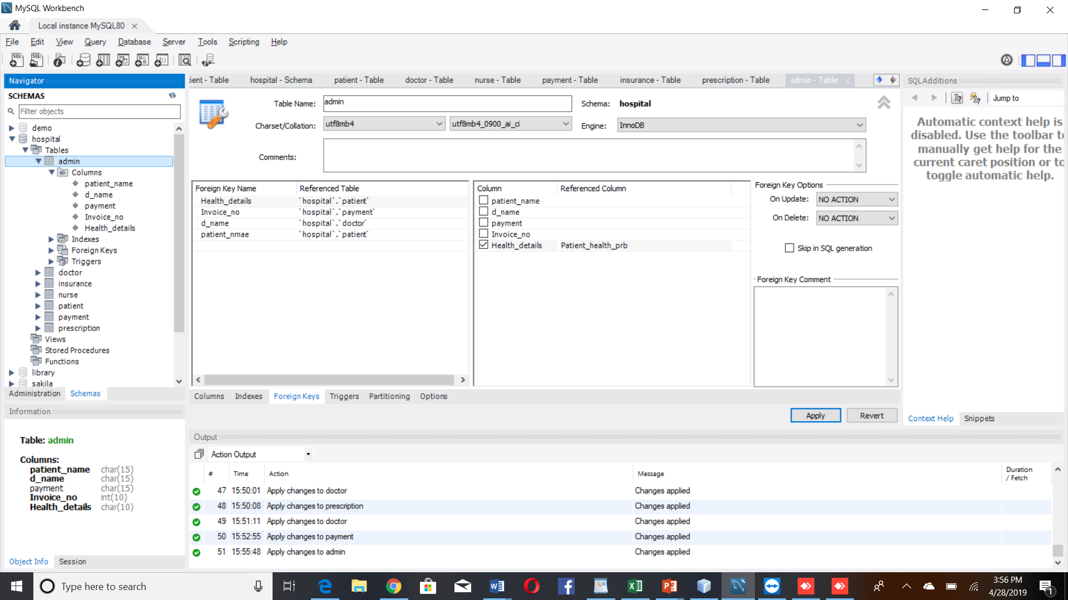

**Doctor:**

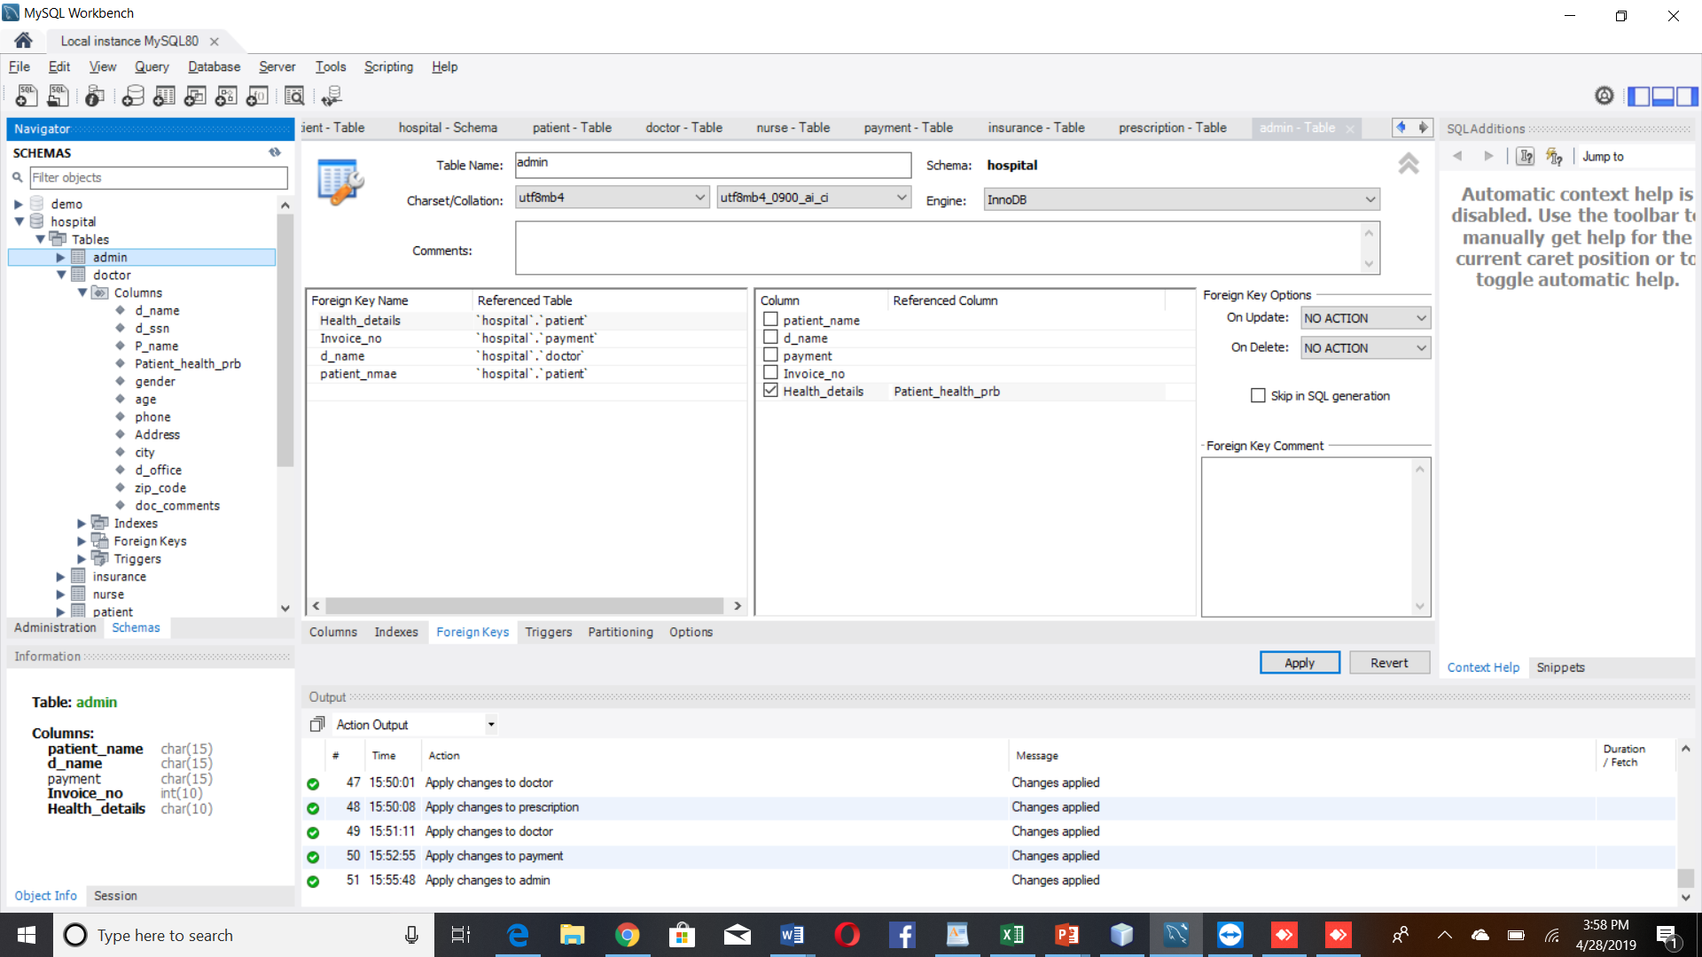

**Nurse**

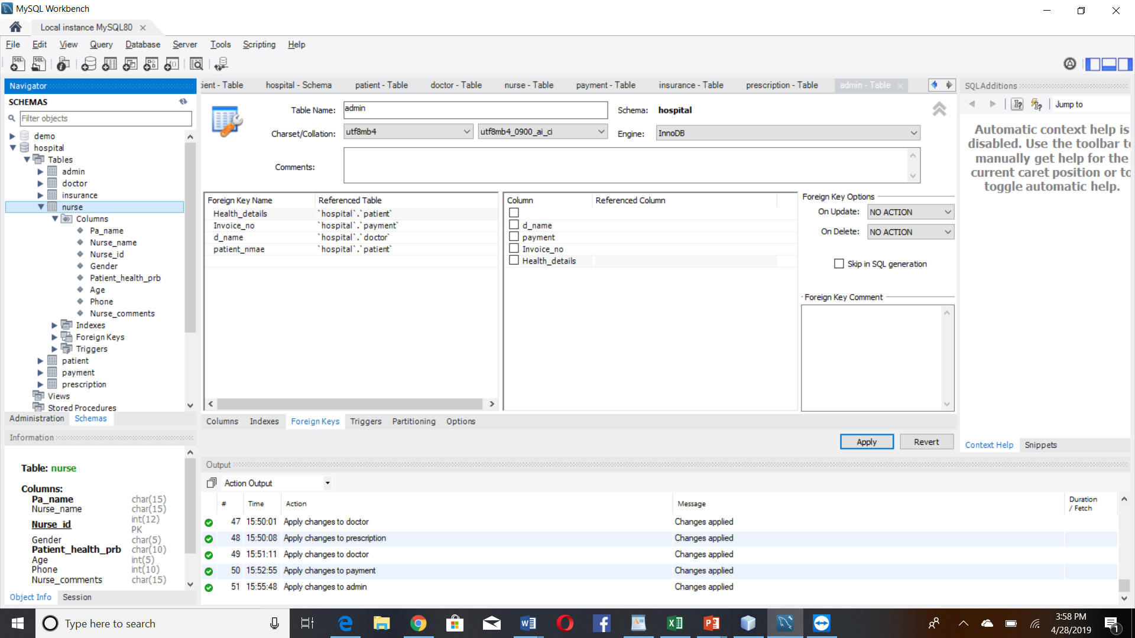

**Insurance**

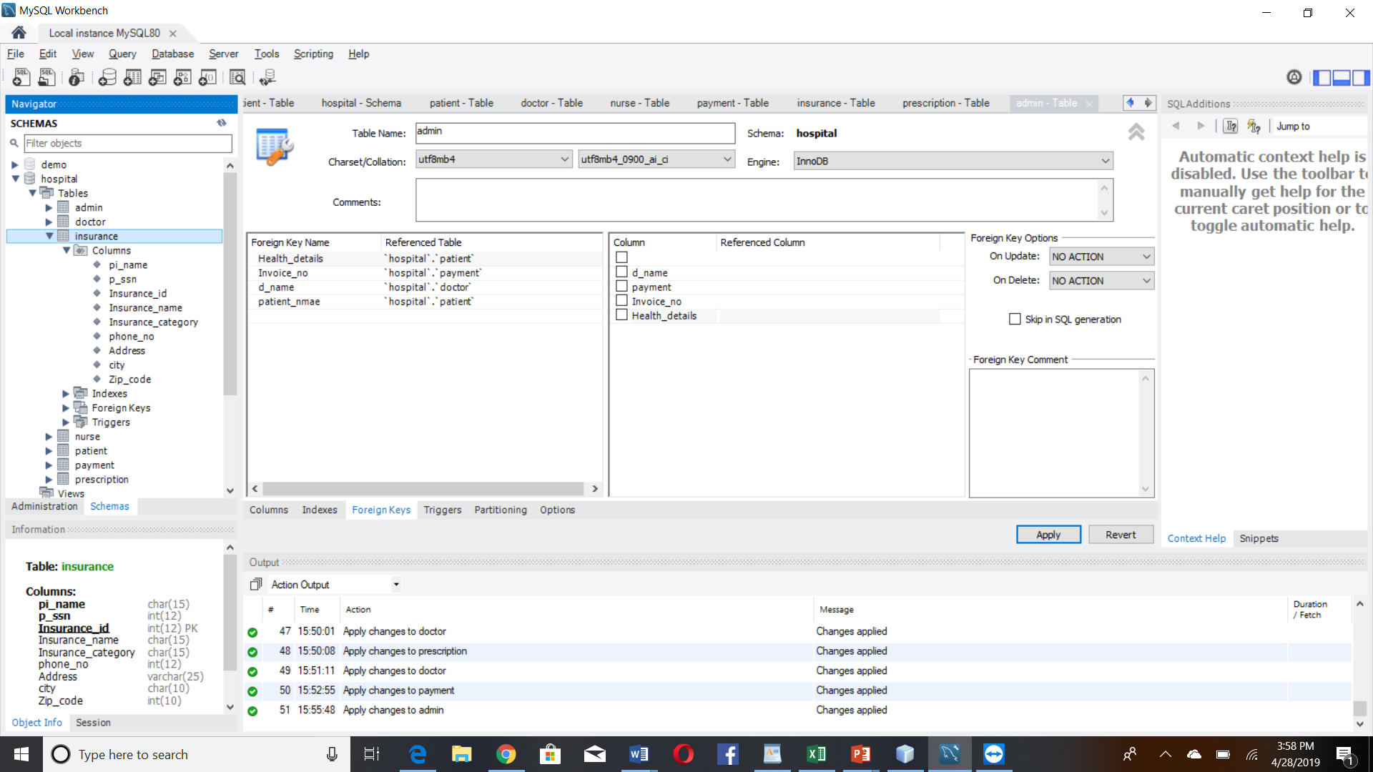

**Payment**

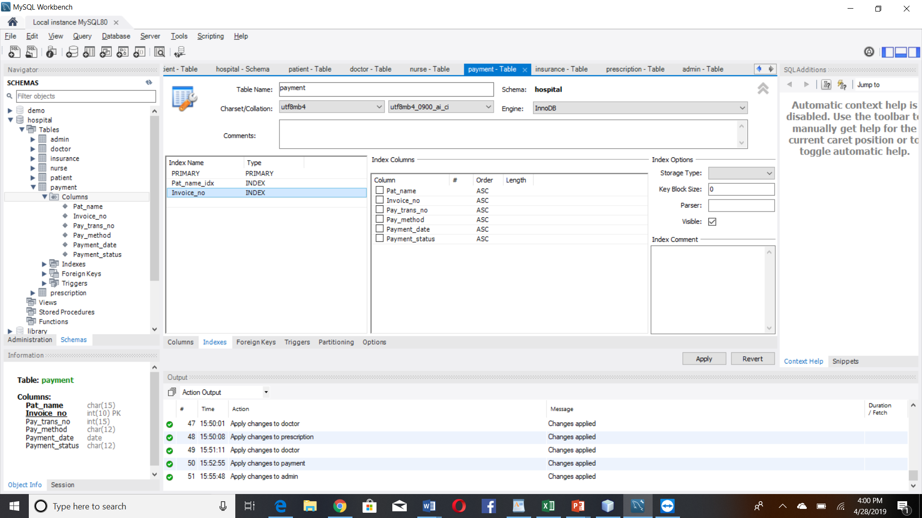

**Prescription**

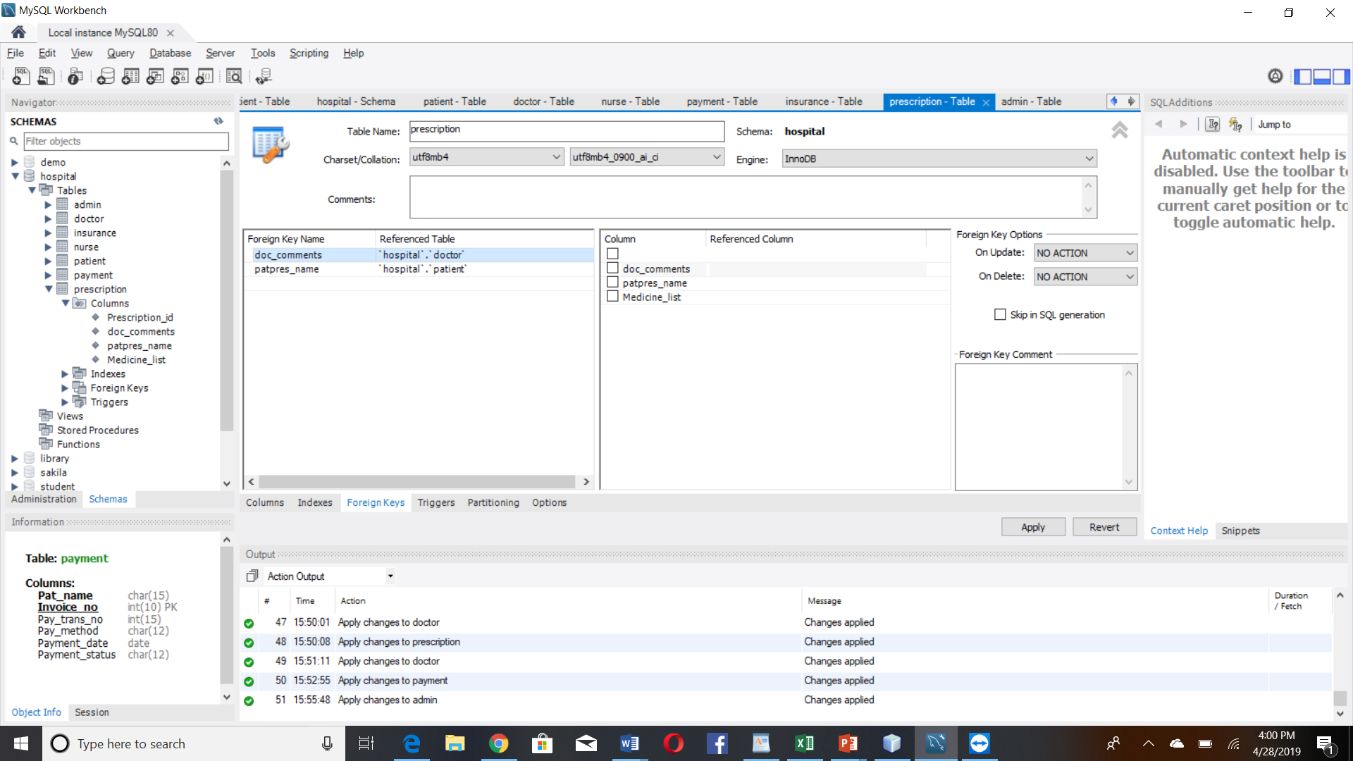

**Admin**

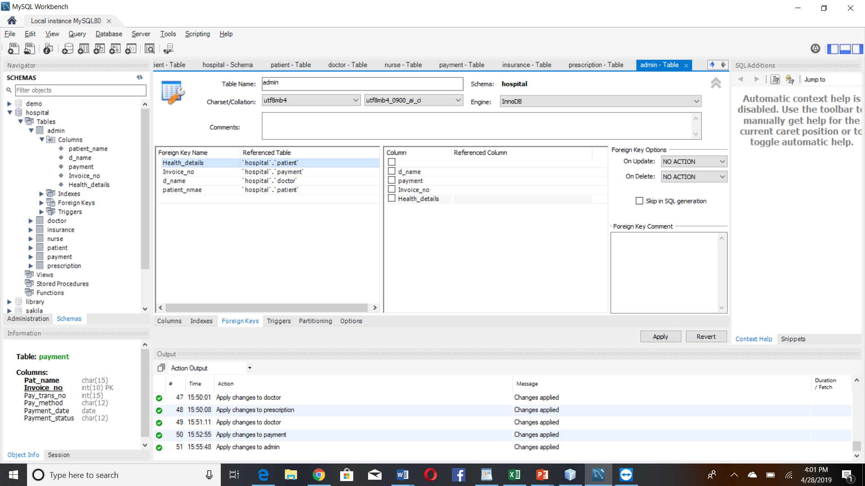

**Table Structure in mySql:**

**Patient**

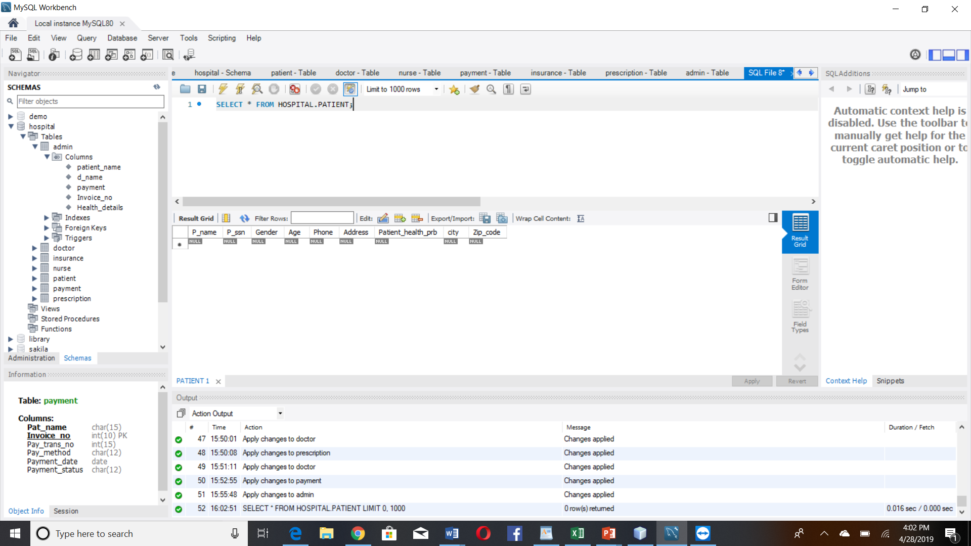

**Doctor**

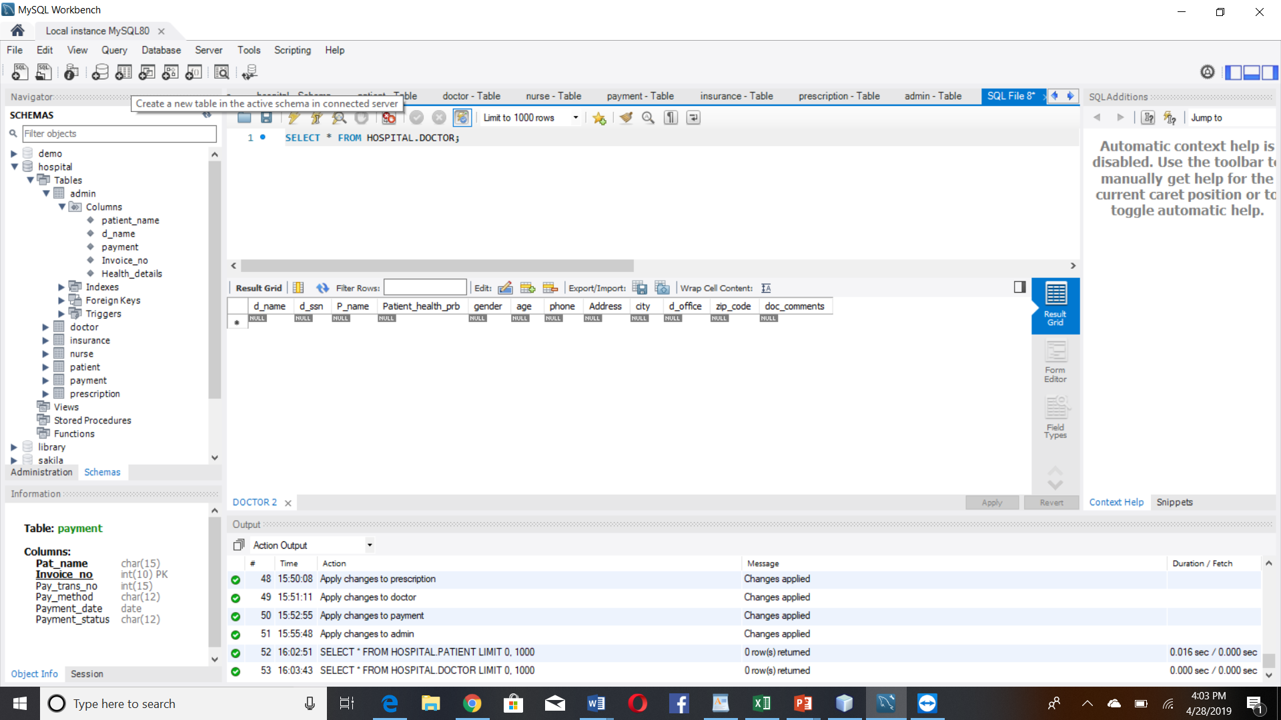

**Nurse**

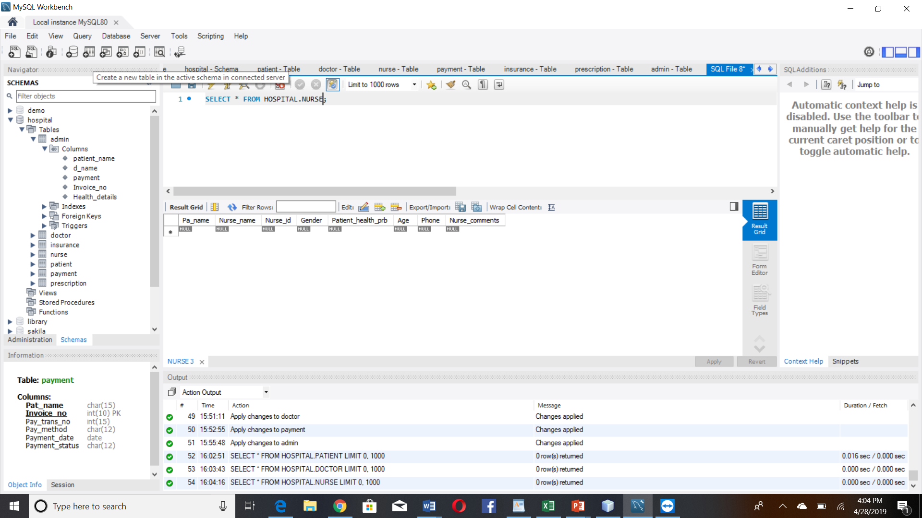

**Payment**

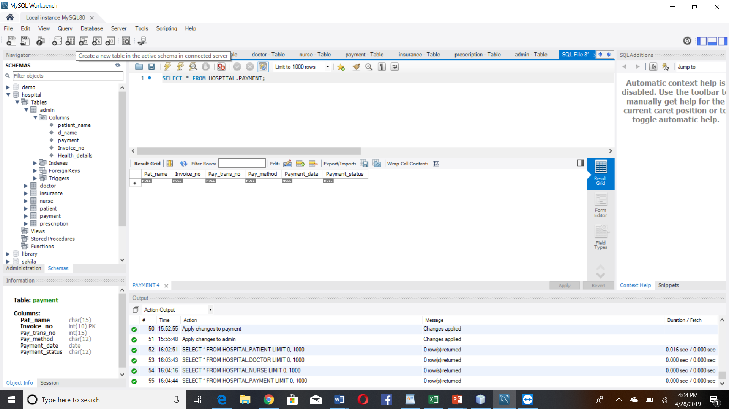

**Insurance**

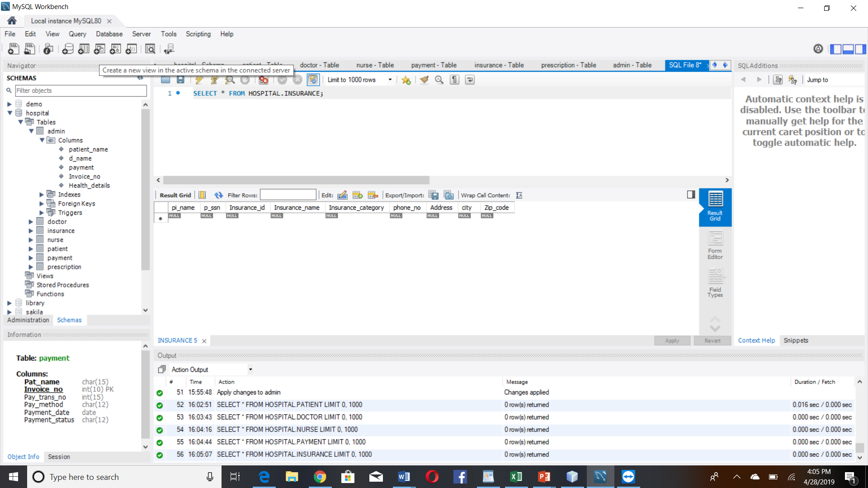

**PRESCRIPTION**

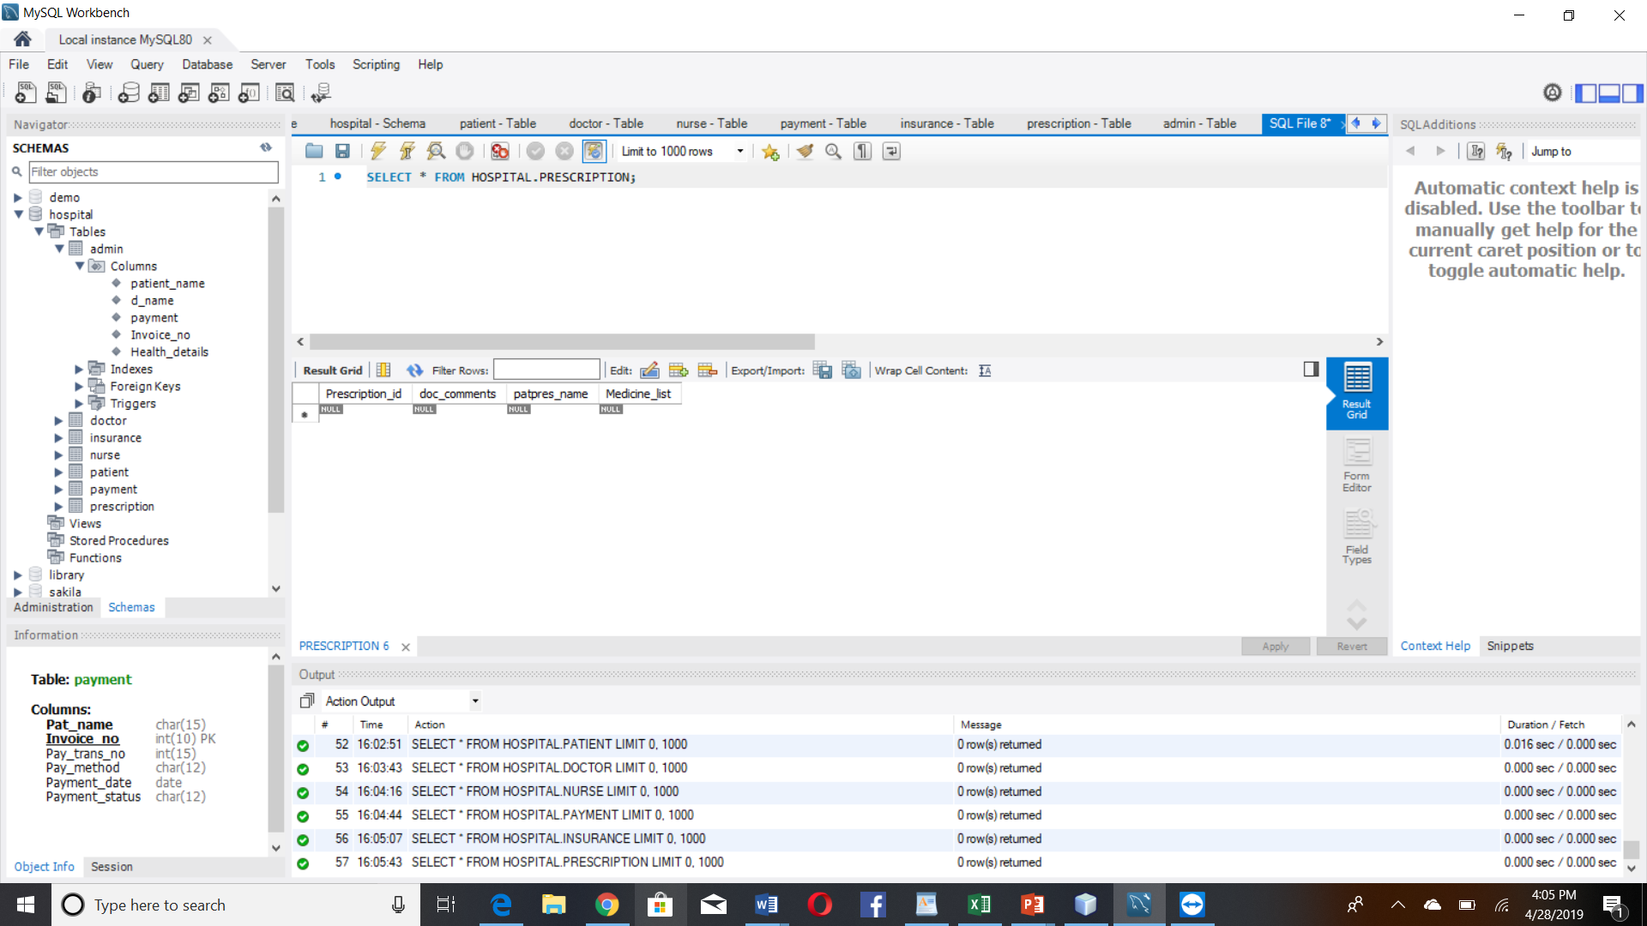

**ADMIN**

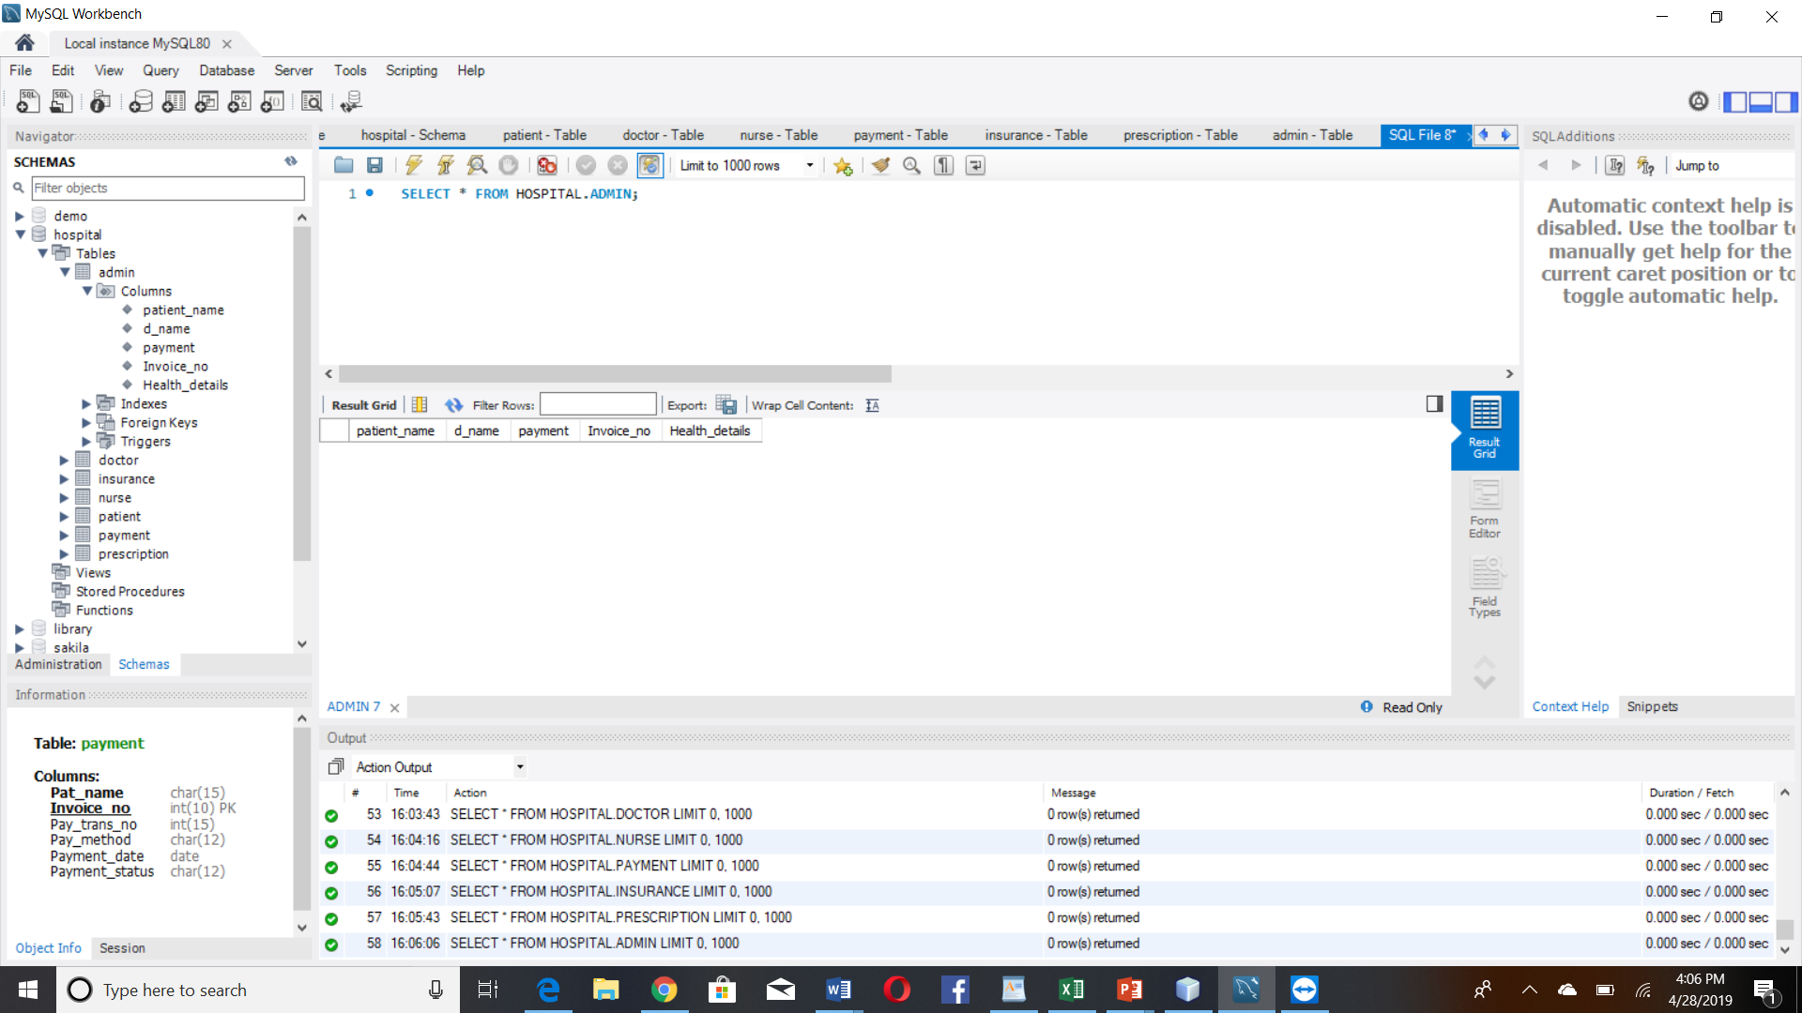

**Netbeans:**

**Patient**

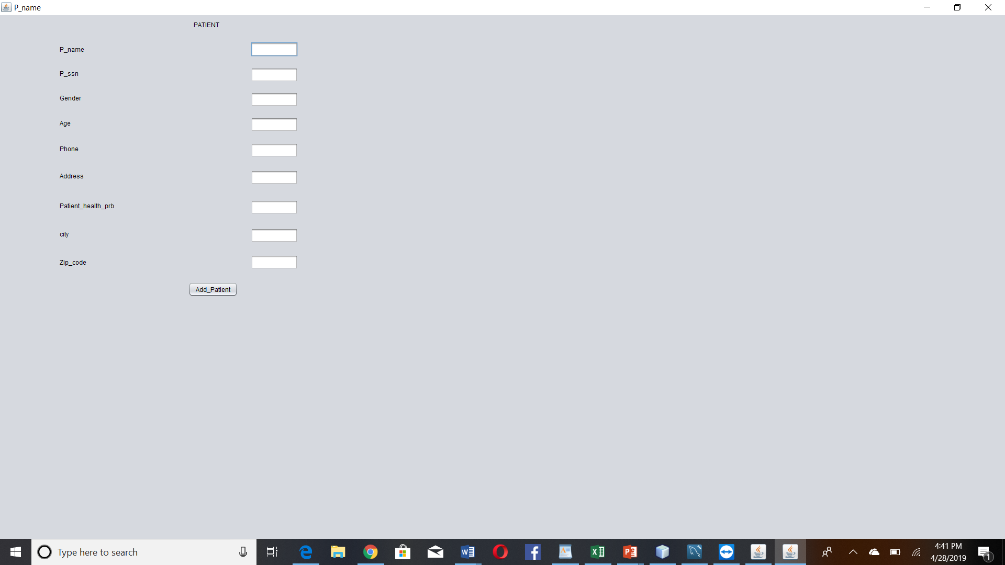

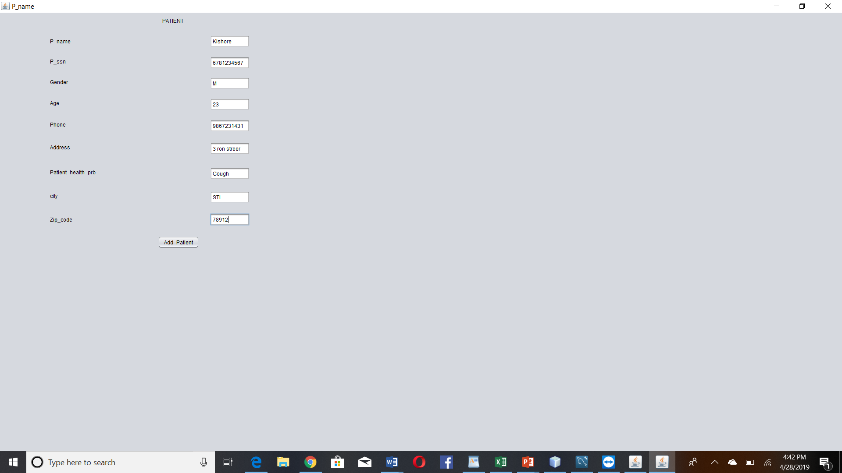

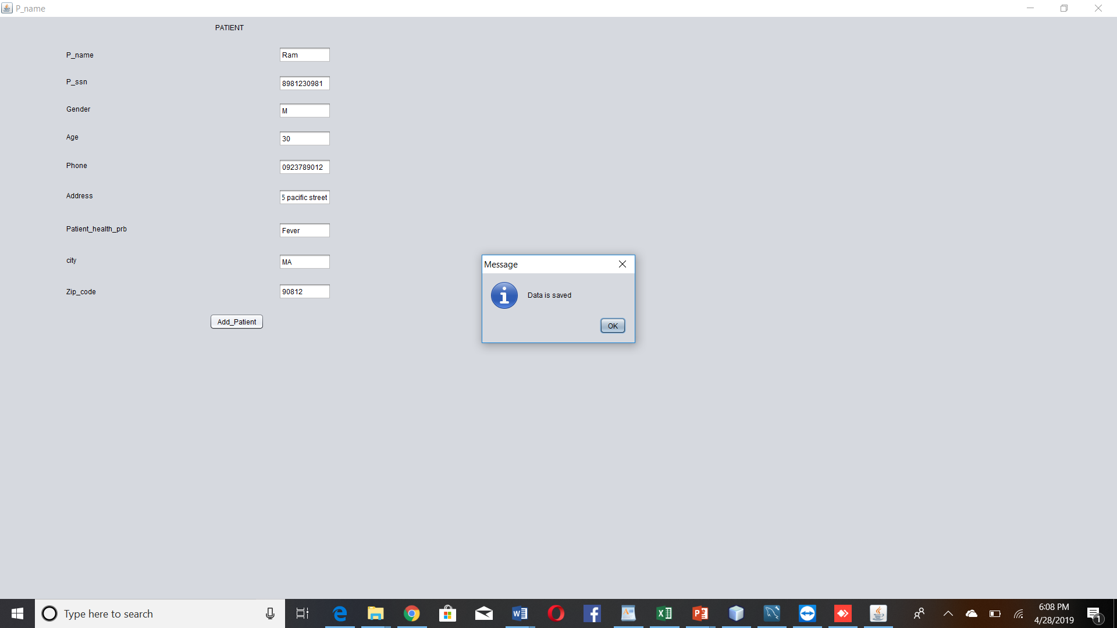

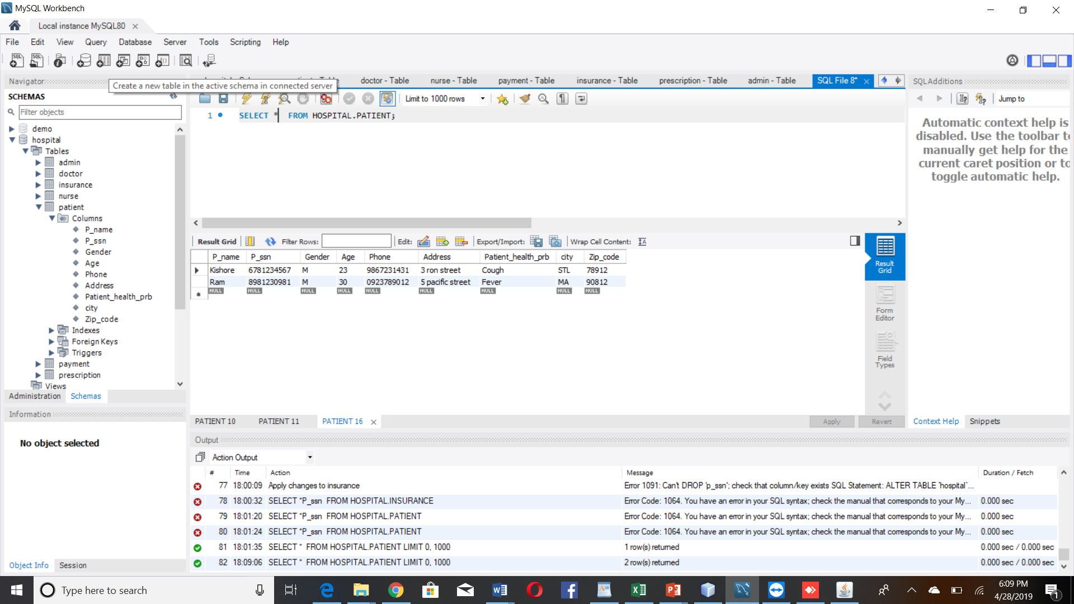

**Source Code:**

**To Insert the values to mysql DB**

private void btn_addToPatientActionPerformed(java.awt.event.ActionEvent evt) {

// TODO add your handling code here:

String P_name = txt_P_name.getText();

String P_ssn = txt_P_ssn.getText();

String Gender = txt_Gender.getText();

int Age =Integer.parseInt(txt_Age.getText());

String Phone = txt_Phone.getText();

String Address = txt_Address.getText();

String Patient_health_prb = txt_Patient_health_prb.getText();

String city = txt_city.getText();

int Zip_code =Integer.parseInt(txt_Zip_code.getText());

Connection conn = null;

PreparedStatement pstmt=null;

try

{

Class.forName("com.mysql.jdbc.Driver");

conn=DriverManager.getConnection("jdbc:mysql:///hospital", "root", "ne$ER1001");

pstmt =conn.prepareStatement("insert into patient values(?,?,?,?,?,?,?,?,?)");

pstmt.setString(1, P_name);

pstmt.setString(2, P_ssn);

pstmt.setString(3, Gender);

pstmt.setInt(4, Age);

pstmt.setString(5, Phone);

pstmt.setString(6, Address);

pstmt.setString(7, Patient_health_prb);

pstmt.setString(8, city);

pstmt.setInt(9, Zip_code);

int i=pstmt.executeUpdate();//will update database

if (i>0) {

JOptionPane.showMessageDialog(null, "Data is saved");

}

else {

JOptionPane.showMessageDialog(null, "Data not saved");

}

}

catch(Exception e){

JOptionPane.showMessageDialog(null, e);

}

**Code to retrieve the patient value from mysql to database:**

package Patient;

import java.awt.BorderLayout;

import java.sql.Connection;

import java.sql.DriverManager;

import java.sql.ResultSet;

import java.sql.ResultSetMetaData;

import java.sql.SQLException;

import java.sql.Statement;

import java.util.ArrayList;

import java.util.Vector;

import javax.swing.JFrame;

import static javax.swing.JFrame.EXIT_ON_CLOSE;

import javax.swing.JPanel;

import javax.swing.JScrollPane;

import javax.swing.JTable;

/**

*

* @author neeru

*/

public class Hospital extends JFrame

{

public Hospital()

{

ArrayList columnNames = new ArrayList();

ArrayList data = new ArrayList();

// Connect to an MySQL Database, run query, get result set

String url = "jdbc:mysql://localhost:3306/hospital";

String userid = "root";

String password = "ne$ER1001";

String sql = "SELECT * FROM patient";

// Java SE 7 has try-with-resources

// This will ensure that the sql objects are closed when the program

// is finished with them

try (Connection connection = DriverManager.getConnection( url, userid, password );

Statement stmt = connection.createStatement();

ResultSet rs = stmt.executeQuery( sql ))

{

ResultSetMetaData md = rs.getMetaData();

int columns = md.getColumnCount();

// Get column names

for (int i = 1; i <= columns; i++)

{

columnNames.add( md.getColumnName(i) );

}

// Get row data

while (rs.next())

{

ArrayList row = new ArrayList(columns);

for (int i = 1; i <= columns; i++)

{

row.add( rs.getObject(i) );

}

data.add( row );

}

}

catch (SQLException e)

{

System.out.println( e.getMessage() );

}

// Create Vectors and copy over elements from ArrayLists to them

// Vector is deprecated but I am using them in this example to keep

// things simple - the best practice would be to create a custom defined

// class which inherits from the AbstractTableModel class

Vector columnNamesVector = new Vector();

Vector dataVector = new Vector();

for (int i = 0; i < data.size(); i++)

{

ArrayList subArray = (ArrayList)data.get(i);

Vector subVector = new Vector();

for (int j = 0; j < subArray.size(); j++)

{

subVector.add(subArray.get(j));

}

dataVector.add(subVector);

}

for (int i = 0; i < columnNames.size(); i++ )

columnNamesVector.add(columnNames.get(i));

// Create table with database data

JTable table = new JTable(dataVector, columnNamesVector)

{

public Class getColumnClass(int column)

{

for (int row = 0; row < getRowCount(); row++)

{

Object o = getValueAt(row, column);

if (o != null)

{

return o.getClass();

}

}

return Object.class;

}

};

JScrollPane scrollPane = new JScrollPane( table );

getContentPane().add( scrollPane );

JPanel buttonPanel = new JPanel();

getContentPane().add( buttonPanel, BorderLayout.SOUTH );

}

public static void main(String[] args)

{

Hospital frame = new Hospital();

frame.setDefaultCloseOperation( EXIT_ON_CLOSE );

frame.pack();

frame.setVisible(true);

}

}

**Output:**

